|  |  |
| --- | --- |
| U.S. Radiocommunication Sector  Fact Sheet | |
| **Working Party:** ITU-R WP 7D | **Document No:** USWP7D_24-5B_NC |
| **Ref.** Report ITU-R RA.2126-1 | **Date:** August 15, 2024 |
| **Document Title:** Working Document Towards a Preliminary Draft Revision of Report ITU-R RA.2126-1: Techniques for mitigation of radio frequency interference in radio astronomy | |
| **Author(s)/Contributors(s):**  Frank Schinzel, National Science Foundation  Chris De Pree, National Radio Astronomy Observatory  Karen O’Neil, Green Bank Observatory  Brian Schepis, SpaceX  Jonathan Williams, National Science Foundation  Sarah Marie Bruno, Johns Hopkins University | fschinze@nsf.gov  cdepree@nrao.edu  koneil@nrao.edu  brian.schepis@spacex.com  jonwilli@nsf.gov  sbruno3@jhu.edu |
| **Purpose/Objective:** To update the report RA.2126-1, which was released in 2013, with new techniques and experiences that have emerged in the past decade. | |
| **Abstract:** Expand the report on mitigation techniques for RAS, especially focusing on new experiences and solutions to provide enhanced resilience to existing and emerging active services that would otherwise interfere with astronomical observations. | |

|  |  |
| --- | --- |
| **Radiocommunication Study Groups** |  |
|  |  |
|  |  |
| Received: | **Document 7D/XX** |
| **X September 2024** |
| **English only** |
| United States of America | |
| Working Document towards a Preliminary Draft REVISION Report OF ITU-R RA.2126 | |
| Techniques for mitigation of radio frequency interference in radio astronomy | |

**Summary**

The last revision to Report ITU-R RA.2126 was published in 2013, since then observatories have continued to refine and improve techniques to mitigate interference of active transmission with astronomical data. This revision is intended to update this report with recent experiences and solutions that enhance resilience to existing and emerging active services that would otherwise interfere with astronomical observations.

**Attachment: 1**

ATTACHMENT

REPORT ITU-R RA.2126-1

Techniques for mitigation of radio frequency interference in radio astronomy

(2007-2013)

TABLE OF CONTENTS

Page

1 Introduction 2

1.1 Definition and characteristics of radio frequency interference 2

1.2 Characteristics of astronomical signals 2

1.3 Dealing with radio frequency interference 2

1.4 ITU Standards 3

1.5 Adoption of mitigation methods 3

1.6 Effective observing techniques 3

2 RFI mitigation methodology – Layers of mitigation 4

3 Techniques for mitigating RFI 5

4 Pro-active measures – Changing the RFI environment 6

4.1 Regulatory and coordination measures 6

4.2 Local measures 6

4.3 Pre-detection & post-detection measures 6

5 Spatial excision (nulling) 7

5.1 Multi-antenna systems 7

5.2 Subspace projections 8

5.3 Post-correlation beamforming 8

5.4 Reference antennas and reference beams 9

6 Waveform subtraction 10

7 Anti-coincidence methods 11

8 Temporal excision (blanking and flagging) 12

8.1 Temporal blanking 12

8.2 Antenna-based digital processing 13

8.3 Digital excision at correlation 13

8.4 Post-correlation – Before or during imaging 14

9 Implementation at the telescopes – A strategy 14

9.1 Operational Data Sharing 15

10 Conclusions 16

# 1 Introduction

Mitigation techniques fall into three general categories:

– Preventing radio frequency interference (RFI) signals from entering the astronomical data, including reduction of the Observatory’s vulnerability to RFI signals (§ 4)

– Removing RFI signals from the data in real time (§§ 5.1, 5.2, 8.1, 8.2)

– Removing or reducing the impact of RFI off line, following completion of the observing (§§ 5.3, 5.4, 8.3, 8.4).

## 1.1 Definition and characteristics of radio frequency interference

To a radio astronomer, RFI is any unwanted addition to the cosmic signal that has the potential to degrade or prevent the successful conduct of an observation. The term RFI will be used in this sense throughout this Report. Unlike thermal noise, which has stable temporal stochastic properties (white noise) and can be dealt with through radiometric detection (i.e. long integration times and on-source minus off-source subtraction), an RFI signal is temporally, spatially or spectrally structured and can obscure a deep-space signal or produce a false positive detection.

## 1.2 Characteristics of astronomical signals

Astronomical signals are many factors of ten below the noise floor of the receiving system. Hence the power level at which RFI begins to be detrimental is far lower for radio astronomy than it is for other radiocommunication services. The variety of potential RFI sources is hence very large. They include personal wireless devices, radar glints from aircraft, satellite transponders, commercial broadcast services, automobile spark plugs and many others.

## 1.3 Dealing with radio frequency interference

The working assumption for most astronomical observations is that RFI-corrupted data are unusable, due to the inherent challenges in accurately removing RFI. At the same time ~~However~~, the increase in wireless communication services has resulted in a significant growth in RFI over the past few years. This ~~lends~~ provides powerful motivation to mitigation of RFI from the datasets, enabling scientific usage of data that would otherwise be discarded. The aim of mitigation techniques is to enable astronomical observations to be conducted in densely occupied bands and heavily used radio environments.

## 1.4 ITU Standards

The threshold levels of detrimental interference in radio astronomy bands are given in Recommendation ITU-R RA.769. The percentage of permissible data loss resulting from emissions above these thresholds is specified in Recommendation ITU-R RA.1513.

In the exclusive primary bands listed in RR No. **5.340**, all emissions are prohibited. In the other radio astronomy bands, listed in RR No. **5.149**, administrations are urged to take all practicable steps to protect the radio astronomy service from harmful interference.

## 1.5 Adoption of mitigation methods

Despite much research on RFI mitigation over the last many years, methods other than filtering and simple excision of RFI‑contaminated data are not at present widely used in radio astronomy. This is primarily because more complex forms of mitigation require costly hardware, challenging software development, and/or expert-user capability to exploit during or after an observation. In addition, different techniques need to be applied dependent on the hardware used, RFI encountered, and scientific goals of the dataset, and none of these techniques have proven to be completely reliable. Finally, radio astronomers want to keep control over their data and are hesitant to adopt black box methods of mitigation. . Though many mitigation techniques have been tested, it is notpossible for any of them to address every issue posed by the diverse variety of RFI sources, radio astronomy observations are made with many different aims that require a variety of different techniques and equipment.

## 1.6 Effective observing techniques

For many observing applications, the standard observing modes and signal processing techniques have provided an inherent degree of interference mitigation that proved adequate to obtaining useful astronomical data in the presence of some interference. Even in these cases, though, some information is lost. Here we describe the standard observing techniques and their RFI mitigation effects. Annex 1 provides further details and examples.

For aperture synthesis instruments, “fringe stopping” typically decorrelates the RFI received at widely-separated antennas. This tends to suppress the RFI in the associated correlation products (Thompson, 1982), provided the signal is not received in the majority of antennae. In the case of some synthesis radio telescopes, such interference may still result in a spurious bright source appearing in the maps at the celestial pole, which makes high declination observations difficult or impossible.

New aperture array instruments under development, such as LOFAR in the Netherlands, are beginning to adopt advanced techniques such as spatial nulling (Boonstra, 2005). This is necessary because of its wide, full-sky field of view, its siting in well-populated regions, and its operation in unprotected HF and VHF bands that are crowded with broadcast and wireless radio services.

Perhaps the most vulnerable radio astronomy service (RAS) observations are those made with single-dish radio telescopes, as typically no “fringe stopping” decorrelation is available for these observers. The improvement in sensitivity to astronomical signals afforded by increasing integration time then leads to a proportional increase in sensitivity to RFI signals. The use of phased array and multi-diode antenna on single dish telescopes to null RFI signals has been tested (Deshpande, 2011; Warnick, et al., 2009) but is not in common use.

Total power observations of pulsed phenomenon, such as are common for the observation of pulsars and fast radio bursts, require astronomical signalsed signal (although the RFI still reduces the sensitivity of the observations)

The impact of RFI extends beyond simply preventing or degrading certain observations or types of observation. It also limits the overall productivity of the radio astronomy station by making desirable observations prohibitively difficult or expensive in terms of observing time requirements, processing complexity and operational overheads.

# 2 RFI mitigation methodology – Layers of mitigation

As indicated in § 1, the techniques for data mitigation can be divided into three general categories. In any practical implementation, particular techniques are likely to be implemented at different stages in the data acquisition and processing. The technique to be used at any particular stage depends on the type of observation undertaken (single dish, single interferometer, interferometer network, phased-array, etc., on the type of radio sources being observed, and on the scientific goal of the observations. The probable types of mitigation and stages at which it takes place are:

1) Pre-detection methods applied in the receiver system itself, possibly in connection with the data-taking backend.

2) Digital excision and RFI removal methods may be used before correlation. With the advent of software (SW) correlation, these digital methods may also be incorporated into the correlation process.

3) The application of digital methods after correlation and after data integration or data buffering.

4) Excision and flagging of the collected astronomical data to eliminate the effects of known and unknown sources of RFI.

The performance of all of these methods depends on the interference-to-noise ratio (INR), i.e. on the strength of the RFI relative to the system noise, or on the ratio of system-noise variance to RFI variance. Most methods are only effective when the RFI is clearly detectable within the data and readily distinguishable from the scientific detections, and its effects can usually only be removed down to a level corresponding to the instantaneous noise. A figure of merit for these methods is the processing gain after RFI suppression or reduction, which can be expressed as the ratio of the signal-to-noise ratio (SNR) after processing to the SNR before processing.

The success of any technique depends on the required level of suppression and also on any loss of the signal-of-interest (SOI). The occupied bandwidth of an astronomical signal relative to that of the RFI must also be considered, particularly when considering the cumulative effects of mitigation from several stages. It is to be noted that each applied method can introduce a measure of toxicity (i.e. damage to the data), which results in an incremental degradation of the data quality. The total damage done to data, as a measure of the data loss resulting from (subsequent) mitigation processing is quantified by the ratio of the SNR (after processing) to the SNR (in the absence of RFI).

# 3 Techniques for mitigating RFI

The development of techniques for mitigating RFI present in the analog output of radio telescope receivers has been a rapidly developing field in recent years, spurred on by technological advances that enable real-time signal processing approaches to RFI mitigation. Helpful introductions are provided by review papers (Bell *et al*., 2000; Fridman & Baan, 2001; Ellingson, 2005, Briggs & Kocz, 2005; Baan, 2010; Kesteven, 2010), as well as in conference presentations and summaries (RFI2004, RFI2010).

For the purposes of this Report, a concise taxonomy of mitigation techniques follows:

1) *Pro-active measures*, to change the local RFI environment by means of regulatory or coordination measures. In addition, some modifications to receiving systems may be possible in some circumstances to exclude RFI from observational data by using filters and robust hardware designs.

2) *Spatial nulling,* or adaptive spatial filtering, mitigates persistent RFI by using array beam‑forming techniques or the use of multi-antenna systems. Array beam-forming techniques orient pattern nulls towards sources of RFI. This distorts the nominal instrument beam pattern(s), but in many cases, such as when interference arrives from the direction of the deep sidelobe response, nulls can be formed with no loss of data from the signal of interest. Challenges include the difficulty of accurately estimating the spatial properties of interference, which limits the achieved null depth. Multi-antenna systems work similarly, here recording the RFI to allow for nulling or cross -correlation of the RFI signal.

3) *Waveform subtraction,* in the sense of “subtracting” RFI from the telescope output. This form of adaptive noise cancellation is potentially superior to temporal excision in the sense that the RFI is removed with no impact on the astronomy. This provides a “look through” capability that is nominally freed of the artifacts associated with a simple “cutting out” of data. In addition, methods that use the statistical properties of the data may achieve similar results. However, the tradeoff with respect to temporal excision is usually that suppression is limited by the quality of the estimate of the interference received by the radio telescope.

4) *Anti-coincidence,* broadly meaning the discrimination of RFI by exploiting the fact that widely-separated antennas perceive identical astronomical signals, but differing RFI. Thus RFI makes a contribution to the background noise level at each antenna rather than to the correlated signals.

5) *Excision in the temporal and frequency domain*, in the sense of “cutting out” RFI from the data. For example, RFI consisting of brief pulses in the time domain may be mitigated by blanking the data (or stopping the data taking process) when the pulse is present. In addition, digital methods allow excision of RFI in both the time and frequency domains. A common property of all excision techniques is the loss of astronomical data, with the possible distortion of the remaining data by artifacts introduced by the excision process or left over from the RFI signature.

Though found frequently in the literature, we will avoid using generic terms such as “cancelation” or “mitigation” to classify specific algorithms in the following discussion since these descriptors can ambiguously refer to several of the categories listed above.

The pro-active methods are described in § 4. Spatial nulling (§ 5) and methods involving waveform subtraction (§ 6) have been demonstrated using real or simulated astronomical data, but are in most cases under further development and/or used only in special circumstances. Anti‑coincidence techniques (§ 7) provide a very effective means for identifying data contaminated by RFI that cannot strictly be classified as mitigation, but are rather a means for identifying data that should be removed by temporal excision. Finally, mitigation methods that are frequently or routinely used at observatories are generally based on temporal excision, i.e. deletion of data that is believed to be contaminated by RFI. These methods are described in § 8.

# 4 Pro-active measures – Changing the RFI environment

## 4.1 Regulatory and coordination measures

Coordination with active users and the application of national and international regulations may reduce both the occurrence of RFI at a radio astronomy station and its impact on observations. Improving and strengthening the regulatory framework at national, regional, and international levels plays an important role in protecting passive use of the spectrum: resources in support of this approach are to be found in the ITU-R Handbook on Radio Astronomy (2013), Recommendations ITU-R RA.769 and ITU-R RA.1513, and the CRAF Handbook (Cohen *et al*., 2005).

Coordination zones and radio quiet zones can be used to control RFI from terrestrial sources. Report ITU-R RA.2259 describes the general characteristics, requirements, and implementation considerations for a radio quiet zone, and provides, in its annexes, numerous examples of specific radio quiet zones. Many observatories have local and national regulations that prevent the installation of transmitters in the immediate proximity (within 2-6 kilometers) of an observatory. Large-scale coordination and quiet zones have been implemented for several sites, such as the Mid West Radio Quiet Zone in Western Australia (MWRQZ, 2007), the National Radio Quiet Zone around Green Bank, WV (NRQZ, 1958) and the Puerto Rico Coordination Zone around the Arecibo Observatory, PR (PRCZ, 1998). The environments for new telescopes, such as ALMA in Chile and the two sites for the Square Kilometer Array, are being controlled by forward-looking, national regulations to facilitate the most sensitive observations.

Since it is better to solve RFI issues before implementation, it is important to identify both existing and prospective new transmitters that may affect portions of the radio spectrum of interest to an observatory, keep up with changes in local licensing rules, and recognize trends in spectrum use. Spectrum monitoring may be used to identify nearby transmitters, to locate potential problems, and to perceive trends in the radio environment.

## 4.2 Local measures

Experience shows that observatories are themselves often significant sources of RFI. Computing hardware and electronic installations required for the telescope buildings generate harmonic and broadband emissions that can enter a telescope’s detection system. Identification and elimination of interference from these sources is a high priority for every observatory. RFI-shielded cabinets and Faraday cages for electronics and computing equipment, as well as the reduction of human activity (remote observing) and limitations on the use of consumer electronics all contribute to making an observatory “radio-quiet” (Rogers *et al*., 2005).

## 4.3 Pre-detection & post-detection measures

A standard method for excising RFI in the frequency domain is to install a bandpass or high/low pass filter in a receiver, which results in an insertion loss and substantially raises the system temperature at frequencies close to a band-edge. Super-conducting filter technology can significantly decrease the impact of such filters. Filtering of RAS bands serves to prevent damage due to strong signals outside the bands. It also results in data loss for spectral line, total power, and continuum observations, though it is often essential when RFI occurs at a critical frequency within a receiver’s passband.

Much research has been applied to the design of robust receivers with a high degree of linearity, so that harsh RFI environments do not affect them. Broadband observations are possible when receiver systems are sufficiently linear that no aliasing occurs, no inter-modulation products are generated, and no overloading occurs (Weber *et al*., 1997; Weber *et al*., 2002; Clerc *et al*., 2002, Tuccari *et al*., 2004).

# 5 Spatial excision (nulling)

## 5.1 Multi-antenna systems

Every multiple-antenna array has sidelobes and nulls in its beam pattern that can be used to reduce signals from localized sources of RFI. Manipulation of the antenna outputs may create a spatial response null in the direction of incident RFI (Van Veen & Buckley, 1988). Such methods as a group are known variously as adaptive array processing, adaptive beamforming, statistically optimal beamforming, or adaptive cancelling. A variety of specific algorithms including maximum SNR, linearly constrained minimum variance (LCMV), subspace projection, Wiener filtering, and multiple sidelobe cancelling (Van Trees, 2002; Van Veen & Buckley, 1988) have been studied by a number of researchers for application to radio astronomical observing (Boonstra, 2005; Boonstra & Van der Tol, 2005; Bower, 2005; Ellingson, 2003; Ellingson & Hampson, 2002; Hansen *et al*., 2005; Jeffs *et al*., 2005; Landon *et al*., 2011; Leshem *et al*., 2000; Leshem &Van der Veen, 2000; Nagel, 2007; Raza *et al*., 2002; Van der Tol & Van der Veen, 2005).

In general, an adaptive system using a beam-forming algorithm requires a high INR and is limited to a small number of RFI targets to be tracked during an observation. The RFI sources also need to remain stable and predictable through an observation. Spatial filtering in beam-forming mode for a limited number of RFI sources generally does not degrade the image generated by the main beam.

The basic technique is well known from its applications in military “anti-jam” communications as well as commercial cellular telecommunications applications (Liberti & Rappaport, 1999). In principle, the same techniques are applicable to radio astronomy. In practice, however, there are complicating factors. First is the fact that in radio astronomy, unlike traditional commercial and military applications, RFI is damaging even when the INR << 1. Thus, to be effective, null-forming algorithms must successfully detect and localize RFI at these levels. In contrast, RFI in commercial and military applications is typically not problematic until the INR is ~ 1. For this reason, most null-forming algorithms developed in the context of military and commercial applications are based on the Wiener filter strategy (which includes so-called “power minimization” and “minimum variance” algorithms), which perform poorly for INR < 1 (Ellingson & Hampson, 2002).

It is known that techniques based on Wiener filtering are limited to reducing the INR in proportion to the INR; i.e. it is straightforward to suppress RFI to a level of an INR ~ 1, and relatively difficult to reduce it further. Thus, to make such techniques effective for radio astronomy, additional measures are typically required to increase the apparent INR delivered to the mitigation algorithm; a few of these are discussed below. It is possible to improve nulling performance if auxiliary antenna signals are available to provide a direct look at the interferer with a higher INR (Briggs *et al*., 2000; Jeffs *et al*., 2005).

Radio astronomical observations depend upon the antenna performance (e.g. gain, beam profile, side-lobe distribution). Traditionally, this has been achieved by precise measurement and attention to ensuring that these parameters do not change with time. Variations in the sidelobe pattern may confound the self-calibration algorithms used to produce high-dynamic range images in aperture synthesis interferometry. Maintaining or at least knowing the variation in these parameters as the antenna beam and sidelobe pattern are modulated in order to mitigate interference is a challenge for the signal processing and antenna control systems now in widespread use.

## 5.2 Subspace projections

An alternative to traditional Wiener filter-based null-forming techniques is the class of techniques based on “subspace projections”. The basic idea in subspace projection is that interference can be identified in terms of correlations between the array elements, which in turn can be used to determine beamforming coefficients that result in patterns which reject the interference with little or no effect on the main lobe characteristics. In mathematical terms, subspace projection is a two-step process of:

– identifying the eigenvectors of the spatial covariance matrix (the set of pair-wise correlations between elements) followed by;

– making the vector of beam forming coefficients orthogonal (the “projection” operation) to the eigenvector associated with the interference (the interference “subspace”).

Normally, it is assumed that the interference dominates the power received by the array, so that the interference subspace is always the one associated with the largest eigenvalue of the spatial covariance. This leads to problems when the interference is relatively weak, especially if the INR < 1 (Ellingson and Hampson, 2002). Nevertheless, subspace projection has been shown to have significant advantages for radio astronomy when properly employed (Raza *et al*., 2002). Such techniques are not a panacea for the problem of poor detection and localization performance, but they do offer reduced distortion of the antenna pattern and, to some extent, behaviour that is easier to anticipate and modify. Distortion introduced by this class of techniques can even be corrected in aperture synthesis imaging as a post-processing operation (Leshem *et al*.,2000). A method to eliminate beampattern distortion in power spectral density estimation, while nulling a moving interference source, has also been demonstrated (Jeffs & Warnick, 2008b). Another type of bias distortion caused by nulling beamformers when the interferer is narrowband has recently been identified (Jeffs & Warnick, 2009).

Even though the null is intended to attenuate only signals from a single direction, the temporal spectrum of the SOI is “notched out” at the same frequency as the interferer using an algorithmic solution. It has recently been shown that if sufficient computational resources are available to store and process a several seconds window of data, much deeper nulls can be formed, even with rapidly moving interference, by fitting the time-varying interference covariance structure to a matrix polynomial model (Landon *et al*., 2011).

In general, null-forming is most applicable to mitigation of RFI from satellites, and can be expected to be somewhat less effective against terrestrial RFI. This is because terrestrial RFI is often scattered by intervening terrain, and often arrives at the radio telescope as a dynamically-varying and complex wave front with apparent direction of incidence spread out over a significant angular range. Traditional null-forming techniques are typically degraded in the presence of angle spread, and the problem gets worse with decreasing INR.

## 5.3 Post-correlation beamforming

An alternative to the implementation of spatial nulling in real time is to implement “post‑correlation” beamforming. Particularly for sparse arrays, with relatively long baselines, correlation may be performed first and the beams synthesized afterwards. “Correlation” in this sense refers to the cross-multiplication of independent antenna outputs (e.g. polarizations, or separate antennas in an array), followed by averaging of the spectrum of the products. It is common for single dish radio telescopes to correlate to obtain Stokes parameters and for arrays of dishes to cross-correlate dishes as a step in synthesizing images. The same beamforming weights, which are used with the time series samples of the array output to form the beam, can instead be applied directly to the integrated correlations to obtain an effective total-power-per-beam-per-frequency-channel spectrometer result that is identical to an integrating spectrometer applied to the time series output of the adaptive beamformer. Assuming the RFI sources are localized, their suppression with this method is then achieved by processing short time intervals of the data stream, and applying complex weighting during image processing (Harp, 2005). Computer simulations of post-correlation spatial filtering show that cleaning with an RFI-corrected beam can be effective (Leshem & Van der Veen, 2000). Also included in this category are aperture synthesis imaging techniques, which exploit the correlation products already available to similar ends (see Cornwell *et al*., 2004 for a recent example).

This method is effective in total power or spectrometer observations, but not for time sequence dependent applications such as pulsar processing. It has the advantages that the same correlation computations can be used both to calculate the beamforming weights and then to compute the corresponding beamformer output power for those weights. This can all be done after the fact in post processing using stored, integrated correlations.

## 5.4 Reference antennas and reference beams

Auxiliary reference antennas can be cross-correlated with the primary antennas. As long as the auxiliary antennas receive the desired astronomical signals with very low SNR and the RFI signals to similar sensitivity, it is a simple matter to correct the RFI-corrupted correlation products using the hybrid (telescope output correlated with auxiliary antenna) correlation products. The technique was first described by (Briggs *et al*., 2000), and was later shown to be essentially equivalent to time-domain (“pre‑correlation”) cancellation, with the exception that additional INR is obtained with no special effort through the integration of the correlation products.

Successful experiments using this approach have been done using one of the 14 antennas of the Westerbork Synthesis Radio Telescope as a reference antenna (Fridman & Baan, 2001). This technique shows great promise for the emerging generation of radio telescope arrays, for which it should be possible to synthesize high-gain auxiliary beams from the same antennas, as opposed to requiring additional “physical” antenna elements.

Correlators for modern radio telescopes are extraordinarily complex and expensive systems. So, this approach requires a significant increase in the capacity of the correlator in order to compute the required additional correlation products and apply them to achieve RFI cancellation. Furthermore, the dynamic nature of most RFI signals limits the amount of integration that can be applied for effective use of this technique: “dump times” on the order of tens of ms may be required to mitigate satellite signals or signals which experience multi-path fading. The necessary increase in the capacity of correlators combined with reduced dump times may increase cost and complexity beyond practical limits, and the increased degree of data processing will result in some degree of data degradation.

Smart antenna techniques, using multiple sensors in radar and communication systems, are used to determine the direction-of-arrival and to implement beam-forming algorithms. Similarly, multiple‑sensor, new-generation telescopes with a direct view of identified RFI sources (such as LOFAR and the Murchison Widefield Array) allow the beam-forming process to be optimized to include real-time, adaptive nulling and spatial filtering of these distinct RFI sources (Van Ardenne *et al*., 2000; Bregman, 2000). In a practical implementation, one hundred LOFAR antennas were used to generate two separate beams, while placing a permanent null at one position 15 degrees above the horizon (Leshem *et al*., 2000). Well-calibrated, multi-sensor, phased arrays offer the possibility of steering a null to track a satellite, while maintaining a high-gain beam on a target field (Fridman, 2005). However, the processing complexity increases rapidly when coping with a multi-satellite system.

Focal plane array (FPA) systems and multi-beam receivers provide new opportunities for spatial filtering, as each of the component feeds has an independent sky signal together with the common RFI signal (Boonstra & Van der Tol, 2005; Hansen *et al*., 2005; Kocz, Briggs & Reynolds, 2010). In addition, one of the feeds in a multi-beam system can always be used as a reference antenna.

Overall, spatial nulling techniques remain largely untested due to their high complexity and the large engineering costs associated with development and implementation. Even in the most favourable situations, the data obtained will not be of the quality that would have been the case in the absence of interference.

# 6 Waveform subtraction

As adaptive noise cancellation (ANC) is often used in both communications and military technology, there is a considerable body of experience in the use of waveform subtraction algorithms (Haykin, 2001). The basic principle of temporal adaptive filtering is to make a FFT from the incoming data, perform an adaptation operation on the frequency bins, and then return to the frequency domain via an inverse FFT. This method, based on Wiener filtering, works for interfering signals with a significant INR, i.e. when the RFI dominates the system noise. The suppression of the interfering signal can be about equal to its instantaneous INR. Adaptive filters are effective when spectral information is unimportant, such as in pulsar (Kesteven, 2005) and continuum studies. An equivalent process can also be implemented in the frequency domain.

An optimal single-dish temporal cancellation algorithm involves the following steps:

*Step 1:* Detection and estimation of the RFI waveform.

*Step 2:* Synthesis of a noise-free version of the RFI waveform.

*Step 3:* Subtraction of the synthesized RFI waveform from the afflicted data.

This strategy was investigated first in the context of radio astronomy by Barnbaum & Bradley (1998), who used a “least mean squares” (LMS) algorithm with a technique based on Wiener filter principles. But the applicability of this technology to radio astronomy is limited by the need for an input INR > 1 in order to achieve significant benefit. To achieve an output INR << 1 using this method, it is usually necessary to implement some means to receive the RFI with an INR greater than the INR perceived by the primary instrument. One way to achieve this is to use a separate directional antenna to receive the RFI (Barnbaum & Bradley, 1998). Since most large dishes have a sidelobe gain that is approximately isotropic in the far sidelobes, the INR can be improved approximately in proportion to the forward gain of the auxiliary antenna used to receive the RFI. Thus, for example, a yagi with a 20 dB gain could improve the INR available to the cancellation algorithm by about 20 dB, which could then reduce INR at the telescope output by a comparable factor. Subsequent work (Jeffs *et al*., 2005) describes the extension of this “reference signal” approach to achieve better performance against RFI from satellites by using multiple auxiliary signals from dishes with gains on the order of 30 dB.

Another perspective on this performance issue from a more theoretical viewpoint is provided by (Ellingson, 2002), who found that the suppression achieved by a cancellation algorithm is approximately upper bounded by the product of the input INR and *L*, the number of samples used to estimate the waveform parameters, assuming a noise bandwidth equal to the Nyquist bandwidth, and is otherwise scaled by the ratio of the noise bandwidth to the Nyquist bandwidth. So, for example, to suppress a signal with INR equal to –20 dB by an additional 20 dB requires analysis of at least 10 000 Nyquist-rate samples, and proportionally more if the noise bandwidth is less than the Nyquist rate. Of course, the signal characteristics must also be stationary over this timeframe, so this can easily become the limiting factor.

A limitation of cancellation techniques that employ auxiliary antennas to obtain a reference signal with high INR is that such techniques can easily degrade into excision. For example, a single-dish radio telescope combined with a high gain auxiliary antenna can behave as a two-element array, with the result that the cancellation algorithm may synthesize a pattern null in the direction of the RFI, with the same consequences as those described above that are associated with null-forming. Yet another consideration is that it is a potentially onerous task to localize and point reference antennas for every source of RFI that affects an observation.

An alternative temporal cancellation approach that avoids these difficulties is to synthesize distinct reference signals directly from the telescope output itself, by exploiting *a priori* knowledge of the modulation characteristics. For example (Ellingson *et al*., 2001) demonstrated a technique for mitigation of RFI from a GLONASS satellite by partially demodulating the signal and then re‑modulating the result to obtain a noise-free estimate of the RFI. They demonstrated a reduction of the INR by more than 20 dB despite the fact that the RFI was received with INR on the order of   
–20 dB. In this case, the INR “deficit” was overcome by the effective increase in INR associated with the process of demodulation. It should be noted that this same technique could also be used to further improve the INR obtained by using auxiliary antennas.

Unfortunately, signal modulations of the type used by GLONASS (i.e. direct sequence spread spectrum) represent only the “low hanging fruit” with respect to one’s ability to obtain large INR improvements through partial demodulation. Most other signals do not exhibit such large improvements with similar processing, and less can be done if the modulation is analog or has unknown structure. For example, work by (Roshi, 2002) on a similar strategy for analog TV signals achieved only about 12 dB suppression despite beginning with an initially large INR, and work by (Ellingson & Hampson, 2002) demonstrated suppression on the order of 16 dB against radar pulses using an estimate-synthesize-subtract strategy. A recent implementation of adaptive filtering techniques aims to remove the signature of the L3 transmission from a single GPS satellite at the Arecibo Observatory (Nigra *et al*., 2010).

This cancellation methodology has also been used effectively with multi-feed or focal plane arrays on single dishes. A variation on adaptive filtering is to subtract a reference data-channel from a signal data-channel using a copy of the RFI itself, by comparing on-source plus RFI and off-source plus RFI signals.

In summary, while nominally more desirable than excision, temporal cancellation involves a significant risk that the waveform is not properly estimated, and therefore not completely removed when the synthesized waveform is subtracted. Whereas the performance of excision is limited primarily by one’s ability to detect RFI, the performance of cancellation is limited primarily by one’s ability to estimate the RFI waveform. The price paid for the benefit of the “look through” capability offered by cancellation is performance that is potentially limited and less-robust than comparable excision techniques. Yet, innovative and useful work continues in this area: the productive use of adaptive cancellation has been demonstrated in pulsar astronomy (Kesteven, 2005), and the use of real-time hardware has been demonstrated for implementing adaptive cancellation (Poulsen, 2003).

The ability to cancel interference by waveform subtraction is limited by the quality of the cancellation waveform as an estimate of the interference waveform received by the radio telescope. Any shortcoming in this estimation process results in some degree of data degradation.

# 7 Anti-coincidence methods

Instead of mitigating RFI, anti-coincidence techniques detect its presence in data. These techniques exploit the fact that widely-separated antennas perceive astronomical signals identically, but RFI differently. The primary use of this technique is in searches for astronomical transients, which are otherwise severely limited in practice by impulsive RFI. Depending on the range of the interfering signals, separations on the order of hundreds of kilometres may be required: this is of course an awkward strategy to use, except in the rare cases where similar telescopes are suitably separated while sharing the same field of view. Cancellation cannot be perfect, and residual random fluctuations do result in data degradation. Nevertheless, this technique has been successfully applied to all-sky transient searches (Katz, 2003) and to searches for one-time “giant” pulses from pulsars (Bhat *et al*., 2005).

# 8 Temporal and frequency excision (blanking and flagging)

## 8.1 Temporal blanking

Temporal blanking is perhaps the oldest and best-known strategy for real-time mitigation of pulsed RFI, and has been used as a response to ground-based aviation radars operating in the 1 215‑1 400 MHz band. These typically transmit pulsed fixed-frequency or chirped sinusoidal waveforms with pulse lengths of 2-400 µs with 1‑27 msec between transmitted pulses and bandwidths on the order of 1 MHz.

These pulses are often detectable through the sidelobes of radio telescopes situated hundreds of kilometres away. Although the transmission duty cycle is relatively low (typically less than 0.1%), accurate blanking is made difficult by the short interval between pulses, as well as by multi-path reflections from terrain features and aircraft generate additional copies of the pulse, which arrive long after the “direct path” pulse (see, e.g. appendix of [Ellingson and Hampson, 2003]). It is common for multi-path pulses to be strong enough to corrupt the astronomical observations even though they are too weak to be detected reliably. Thus, a blanking interval triggered by a detected pulse must typically be many times longer than the detected pulse, in order to ensure that all of the multi-path copies are blanked. Blanking intervals with lengths up to 100’s of microseconds (i.e. 10‑100 times the pulse duration) are typically required (Ellingson and Hampson, 2003).

A number of real-time techniques for temporal blanking or cessation of the data-taking process have been developed to various degrees (Fridman, 1996; Weber *et al*., 1997; and Leshem *et al*., 2000), The National Astronomy and Ionosphere Center (NAIC) has developed a device for real-time mitigation of strong pulses from the local airport radar at the Arecibo Observatory (Puerto Rico). This works by tracking the arrival time of the leading edge of the pulses, and then blanking the output of the receiver in a time window around the expected pulse arrival times. tailored to encompass the consequent radar artifacts from terrain and multi-path scattering. More recent work in this area, including experimental results, is described in Ellingson & Hampson (2003), Fisher *et al.* (2005), and Zheng *et al*. (2005), with the last two references addressing the similar problem of pulsed interference from aviation distance measuring equipment (DME).

The primary limitation for the blanking approach is detection performance, since an RFI pulse is detected, it can be completely removed by blanking. However, it is inevitable that some fraction of weak pulses will not be detected. Over the time-scale of a single pulse, however, astronomical signals routinely have a signal-to-noise ratio (SNR) <<1, so RFI must be reliably detected at these levels in order to be effectively suppressed in the integrated output. This is quite difficult: the recent successes cited above are attributable to detailed advanced knowledge of the RFI waveform, which is used to compensate for an inadequate SNR in detecting the radar pulses.

Further improvements in detection performance appear to be feasible using aspects of the RFI waveform that can be exploited without specific knowledge of the waveform. Thus cyclo‑stationarity has been applied by Britteil & Weber (2005) to the HIBLEO2 (Iridium) Satellite signals, while Dong *et al.* (2005), have applied Kalman tracking to aviation radar, which also improves detection performance at lower interference to noise ratios (INR). Another challenging problem is presented in determining exactly how to set detection thresholds and blanking window lengths so as to achieve an acceptable tradeoff between robust RFI mitigation (which suggests low thresholds and long windows) and limiting degradation of sensitivity and the introduction of blanking artifacts (which suggests high thresholds and short windows). This problem was studied by (Niamsuwan *et al*., 2005). Nevertheless, “blanked” time is lost observing time that requires an increase in the observational time to achieve the desired sensitivity Additionally, any remnant signal from the RFI can readily result in false or incorrect detections for the scientific data, making the results unreliable.

## 8.2 Antenna-based digital processing

Real-time digital processing may be implemented as part of the signal chain of a single-dish radio telescope (RT), and as part of the station processing and/or beamforming process for array instruments. This cost-effective method works well for impulsive (transient) RFI and requires fast data sampling as well as the availability of sufficient computing cycles at each of the stations (Fridman & Baan, 2001; Niamsuwan *et al*., 2005; Ellingson & Hampson, 2003). The amount of data loss is determined by the transient nature of the RFI. Real-time, IF-based flagging and excising minimizes the data loss incurred by the flagging – excision method by only dealing with the RFI‑infected time and frequency segments; this should not inflict collateral damage on neighbouring time and frequency intervals. This differs from post-correlation processing (next section), which is more vigorous as integrated data samples are used for baseline and antenna flagging and excising. Thresholding in both the temporal and frequency domains may be applied when the RFI in sampled data is strong and identifiable, and the spectral occupancy of the RFI is relatively low. Thresholding was first used to remove RFI at the Ratan 600 m telescope (Berlin & Fridman, 1996). A recent application was at the Westerbork Synthesis Radio Telescope (WSRT), where 20 MHz dual‑polarization IF data from each of the fourteen telescopes was processed in real‑time (Baan *et al*., 2004; Baan *et al*., 2010). This thresholding method has also been applied to pulsar data prior to period folding (Fridman 2009; Fridman, 2010).

Another form of sub-space excision exploits the probability distribution analysis of signals. Since the RFI contribution changes the power spectrum to a non-central (chi-square) distribution, as determined by its higher moments, it can be removed from data (Fridman & Baan, 2001; Fridman, 2001). A similar approach exploits kurtosis (4th moment of the power spectrum) to identify and remove the RFI component. Kurtosis has been used as the RFI discriminant for single-dish real‑time solar observations by Nita *et al*. (2007), & Gary *et al*. (2010), and by (Deller 2010) for post correlation processing in a software correlation environment. Median filtering and taking advantage of the median properties of a multi-feed system, also exploit the statistical properties of data and are effective in the real-time mitigation of RFI in spectral-line data (Kalberla, 2010; Flöer *et al*., 2010).

Pre-correlation mitigation methods that involve the removal of data samples necessarily change the gain calibration of data. So the use of these methods requires accurate bookkeeping to determine their effect on data and associated data loss. On the other hand replacing affected data in the frequency (or time) domain with a fitted baseline only affects the rms of affected channels, although here this replacement could affect the perceived strength of the astronomical signal, if it lies within the affected channels.

This kind of data blanking has been implemented in production for the Karl G. Jansky Very Large Array (VLA) Wideband Interferometric Digital Architecture (WIDAR) correlator. The WIDAR Station Boards provide a capability to excise or "blank" impulsive radio frequency interference on microsecond timescales, thus avoiding the corruption of the longer visibility integrations that are typically accumulated over a few seconds. This mode is particularly effective at identifying and blanking interference from radar transponders, especially those used for aeronautical navigation between 1.0 and 1.2 GHz. The blanking applies to the voltage sample time-series recorded for each subband on a per station (i.e., antenna) basis before cross-correlation. The voltage samples are recorded at 256 megasamples per second (~4 ns) and sample values that exceed a dynamically set threshold are flagged as bad data for a fixed dwell time and ignored. Thus by blanking in time, the whole subband is effectively blanked in frequency. Typical fractions of blanked data are approximately 0.1% of data per integration per subband.These techniques have proven to work well within limited cases, and research is still underway to increase the opportunities for pre-correlation mitigation.

## 8.3 Digital excision at correlation

As part of the correlation process, digitized data are generally integrated over time intervals ranging from the sampling time up to seconds, which significantly raises the INR. In consequence, persistent but weak RFI, that could not be treated in real-time, and weak (spectral) remnants of earlier mitigation operations become accessible for processing. On the other hand, significant peaks of a time-varying RFI signal may also be reduced in strength by the integration process. For array instruments, spatial filtering resulting from delay (fringe) tracking of a celestial source also reduces the strength of terrestrial RFI in cross-correlated data.

At this point in the data taking process, anti-coincidence protocols may be incorporated to identify the RFI components, as well as digital mitigation processing and the utilization of data from a reference antenna. New generation software correlators permit the integration of kurtosis-based flagging applications before and after FX (Fourier Transform before multiplication) correlation and stacking protocols (Deller, 2010). Mitigation at several processing stages is being implemented for LOFAR (Bentum *et al*., 2008). In the case of single-dish instruments the correlation processing of (multiple) single bands may incorporate both thresholding or statistical methods and noise cancellation with a reference antenna.

Subspace filtering methods may also be implemented in a digital correlation system to search for a particular signature in the RFI power component of data in order to identify and remove it. A particularly successful application is the search for cyclo-stationarity within data, which works well for digitally modulated RFI signals (Weber *et al*., 2007; Feliachi *et al*., 2009, 2010).

Deploying digital processing and input from reference antennas during software correlation is equivalent to their use in baseband pre-correlation processing. But the implementation of these algorithms into pre-existing hardware backends requires the addition of both special hardware and software. As with the pre-correlation excision techniques, this method remains limited as there is still considerable research to improve and generalize the algorithms, thereby increasing the variety of RFI on which the technique can be accurately used, and decreasing any remnant signal from the RFI.

## 8.4 Post-correlation – Before or during imaging

Traditional post-correlation processing consists of flagging and excising, which is time consuming and often done at least partially manually (Lane *et al*., 2005). Because this operation is performed on integrated and correlated data, the data loss resulting from flagging can be quite significant, the more so as whole time-slots, whole baselines, and/or whole antennas may be flagged. This differs from antenna-based signal-chain flagging or excising where small subsets are flagged, which inherently results in a smaller proportion of data loss overall.

On-line or off-line processing of (integrated) correlated data makes it possible to incorporate automated flagging and excision (Middelberg, 2006; Offringa *et al*., 2010, 2012; Keating *et al*., 2010; Sirothia *et al*., 2009ab), as more sophisticated statistical or sub-space processing (see § 8.2) can be implemented to remove the RFI component without as much data loss. There are many techniques in use for post-correlation mitigation of RFI signals, and the choice of technique to use is dependent primarily on the type(s) and density of RFI present, hardware used for the observations, and the scientific goal of the data set. A few of the common methods are listed below, and demonstrated in Annex 1.

Briggs, et al. (2000) implemented a reference antenna at the post-correlation stage to remove the signal from a well-defined RFI source using the available closure relations.

Array instruments employ fringe-stopping and delay-compensation techniques to keep a zero fringe rate at the central observing position during observations. As a result the stationary (terrestrial) and satellite RFI components in data distinguish themselves by fringing faster than components from astronomical sources. This distinctive (relative) motion allows the off-line identification and elimination of stationary RFI sources from both the correlated data and the image plane without causing data loss (Wijnholds *et al*., 2004; Cornwell *et al*., 2004; Athreya, 2009). The coding for this operation from the GMRT is now incorporated into AIPS (Kogan & Owen, 2010).

Another emerging and powerful method are algorithms that perform RFI flagging in the Fourier domain. For example, one can take advantage of redundancy of complex visibilities inside the Fourier image plane to identify corrupted data or use a scheme to detect faint RFI in the complex visibility time-channel plane of individual baselines (Sekhar & Athreya, AJ 2018).

# 9 Implementation at the telescopes – A strategy

The data acquisition process of radio astronomy observatories is evolving to cope with the rapidly changing technological environment. Analog to digital conversion of signals now occurs as early as possible in the data-handling scheme, which allows digital processing throughout most of the data chain. Increased instrumental capabilities allows for the processing of larger bandwidth data, with higher time-resolution and higher frequency (< kHz) resolution.

Many current signal processing systems do not allow the implementation of mitigation at early stages of the data handling chain without incurring (severe) hardware modifications. By contrast, new-generation backends and software correlation facilitate such schemes at different stages of the processing.

Since every mitigation method requires a definite INR threshold for its operation, removal of most of the RFI requires a layered application of methods to exploit the progressive integration of the data and its increasing INR. While no method can remove RFI below the noise floor it encounters, subsequent mitigation steps may remove remnants of the mitigated RFI, as well as weak RFI that is only apparent after integration.

The implementation of auxiliary antennas for array instruments depends on the possibility of incorporating their output into the processing system (most particularly) at the correlator. Directed reference antennas generally cope with particular RFI sources and are less effective in a complicated environment.

Human intervention in the RFI mitigation process currently plays an important role in practical operations. Thus real-time on-line processing that is adaptable to a variety of RFI signatures may be preferred to the restrictive use of reference antennas and/or spatial filtering for known and fixed transmitters. This is likely to be the case until an artificial intelligence controller can be invoked to guide and dictate the RFI mitigation scheme.

Interferometers are less vulnerable to RFI. Fringe-stopping and de-correlation by delay compensation provide for its natural suppression on the longer baselines. However, strong RFI still adds to the system noise, and still affects the calibration and the complex visibilities of a station. VLBI stations and distributed sensor networks can implement mitigation at every individual station to reduce the impact of local RFI on the whole system.

To correctly calibrate a system, accurate bookkeeping is required for all affected data in order to obtain the correct weights for later self-calibration, cleaning and imaging procedures.

Future mitigation implementations need to consider more sophisticated methods than the simple (kurtosis or other) RFI flagging and excising algorithms that are generally current at this time. The use of statistical methods using higher moments opens the possibility of removing RFI components without affecting the rest of the data, and there are methods that allow partial restoration of data that reduce data loss. Adaptive filtering of spread-spectrum systems may become possible when their digital keying schemes are known. In all cases, though, care must be taken to ensure integrity of the scientific signal, and it should ne recognized that RFI excision remains a poor substitute for mitigation in advance of the observations being taken, regardless of where in the signal chain the excision occurs.

## 9.1 Operational Data Sharing

Designed to minimize horizon-based radio frequency interference (RFI) by their remote locations and suppression of sidelobe gain, radio telescopes have become vulnerable to a variety of space-based transmitters, especially those found in large satellite constellations. Due to the altitude and growing density of constellation satellites, their transmissions are becoming a constant presence and are increasingly difficult to avoid via simple scheduling by radio telescopes, even if sited in the most remote regions of the Earth.

A number of radio astronomy sites have undertaken coordinated and uncoordinated experiments since the launch and deployment of satellite constellations capable of providing broadband internet access. As a result of early results - that distance to RAS telescope boresight was an important parameter (regardless of the Earth-surface location of the downlink beam) - a series of experiments attempted to mitigate this potential for large signals in the sensitive electronics, finally taking shape in a system called Operational Data Sharing (ODS). The simple goal of this technique is to make the real-time activity (sky position, frequency, bandwidth) available to a satellite constellation. Based on this information, the satellite constellation sends commands that cause particular satellites to change their behavior in such a way as to minimize downlink signal strength for the short period of time when the satellite is close to boresight (typically on timescales of seconds). Experiences with one application of ODS are provided in Annex 2.

As a reporting schema, the usefulness of ODS and ODS-like systems is not limited to space-based transmitters. One can imagine communicating in similar way with nearby ground-based emitters from more traditional systems. The appeal of this type of RFI mitigation is that all that is required of RA telescopes is real-time (and rapid) sharing of their current status, resulting in reduced or eliminated signals in the observing band.

[While early tests of the ODS system have been largely successful, there are still significant challenges that this solution will not fully address, including: (1) ODS systems are unlikely to prevent all signals from entering the beam due to sidelobes, scatter, etc; and (2) systems like this might present challenges in terms of implementation due to a variety of factors (satellite systems unable to respond, or unable to respond quickly to the requests; the need for telescopes to respond scientifically to the weather, scientific finds, etc).

# 10 Conclusions

RFI mitigation technology and techniques offer significant benefits to radio astronomy, but more work remains to develop technology that is practical and applicable in routine operations and which ensures the integrity of the scientific data obtained. It is also clear that RFI mitigation technology cannot be regarded as a standalone fix for the external RFI problems experienced by present day and future radio telescopes. Inevitably, the effectiveness of any given technique depends on:

– the architecture of the instrument or its configuration for a particular observation;

– the observing mode and scientific goals (e.g. spectroscopy, continuum, aperture synthesis imaging, pulsar dispersion searching);

– the nature of the RFI itself (e.g. persistent or intermittent, spatially coherent or scattered by multi-path, etc.);

− availability of resources needed to implement computationally intensive algorithms, when required;

− the accuracy of the results and subsequent comfort level of astronomers to use these new techniques and instruments.

Mitigation merely reduces the degree to which data are degraded or obliterated by interference, it does not remove all traces of RFI from the data without effect. Additionally mitigation increases operational costs. The near-term path to bring RFI mitigation into practical use is for researchers in signal processing to work together with astronomers to identify specific, high-value science observations which currently cannot be undertaken due to RFI, for which mitigation algorithms can be applied and tested. It should be noted, however, that no, single technique can address all possible scenarios for radio astronomy observations, nor is one thought to be possible. Mitigations that take advantage of high speed information sharing between active and passive users of the spectrum hold promise and should be pursued.

Both on-line and off-line data processing has been successful in mitigating the RFI environment of radio astronomy observatories. While there is an increasing variety of successful mitigation options, the choice of method depends strongly on the RFI characteristics, the type of radio telescope, and the type of observation. In particular, on-line real-time data-processing may be preferred in a variable RFI environment, while special measures such as reference antennas and spatial filtering may be preferred for known and fixed sources of RFI. In addition to these factors, the absence of human involvement may also render automated on-line processing a more attractive option.

No universal method exists for mitigating RFI in astronomical data and no method can identify or remove RFI within the noise of the system. The effective suppression of RFI depends on the INR and its temporal and spectral characteristics. A quantitative evaluation of the method used is not always possible because mitigation algorithms are generally non-linear processes that also affect the noise characteristics and the gain calibration. The toxicity of the method used, i.e. the negative effect of its invocation on data by the deployed method, and the amount of data loss resulting from the method, are other factors that guide the evaluation of the choice of method.

Multiple methods need to be applied to deal with a more general RFI environment. Because RFI characteristics change after each mitigation step and with increasing integration of the data, the cumulative effect of RFI mitigation at subsequent stages is not a linear sum of what each method can do, but rather the sum of what is practical and possible at each step.

The cost of computing hardware capability and of digitizing components at radio astronomy observatories is rapidly changing. Both upgrades of existing facilities and the introduction of newly constructed instruments provide opportunities for implementing and automating RFI mitigation algorithms. These capabilities also permit increased bandwidth, higher time resolution, and higher spectral resolution. The resulting, increasingly large data volumes will force the introduction of automated data reduction pipelines. Future data volumes are likely to force the acceptance of automated RFI mitigation at radio observatories.

New telecommunication and broadcasting technologies are reaching the market place, many in the form of unlicensed mobile devices. Since their ever-changing locations are impossible to control, they will rapidly affect observatory operations. Algorithmic research is needed to eliminate their signals from astronomical data. In particular, spread spectrum (ultra-wide band) devices will pose problems for passive services, as their digital modulation schemes do not respect the boundaries of spectrum allocations. Current estimates suggest that the number of transmitting devices used by each person is set to increase dramatically and many of these will rely on dynamic spectrum access.

The discovery space for radio astronomy is determined to a significant degree by the technical characteristics of the observing system and by limiting factors such as the RFI environment. While new generation telescopes are located at the most pristine possible sites, existing facilities must coexist with their local conditions. In order to prevent RFI becoming the limiting factor for existing facilities, spectrum management, both internal and external, has to be accorded a very high priority. Both observatory management and astronomers should regard RFI issues as critical.

References

ATHREYA, R. (2009), *A New Approach to Mitigation of Radio Frequency Interference in Interferometric Data*, ApJ 696, 885.

BAAN, W.A. & BOONSTRA, A.-J., 29-31 March, 2010, Groningen, The Netherlands.

<http://www.astron.nl/rfi/presentations.php>

BAAN, W.A., FRIDMAN, P.A. and MILLENAAR, R.P. (2004), *Radio frequency interference mitigation at the Westerbork Synthesis Radio Telescope: algorithms, test observations, and system implementation*, AJ 128, 933.

BAAN, W.A., FRIDMAN, P.A., MILLENAAR, R.P. and ROY, S. (2010), *The WSRT Interference Mitigation System – lessons learned*, PoS (RFI2010) 024.

BAAN, W.A. (2010), *Setting the stage – layers of RFI Mitigation, RFI2010 – RFI Mitigation Workshop, PoS (RFI2010) 001*.

BARNBAUM, C. and BRADLEY, R.F. (1998), *A new approach to interference excision in radio astronomy: real-time adaptive cancellation*, A J 116, 2598.

BELL, J.F., EKERS, R.D. and BUNTON, J.D. (2000), *Summary of the Elizabeth and Frederick White Conference on radio frequency interference mitigation strategies, PASA 3, 17.*

BENTUM, M., BOONSTRA, A-J., MILLENAAR, R.P. and GUNST, A. (2008), *Implementation of LOFAR RFI mitigation strategy, Proc.XX1X GA (URSI Chicago), 348, 2008*.

<http://scholar.google.com/citations?view_op=view_citation&hl=en&user=7mLAYBAAAAAJ&citation_for_view=7mLAYBAAAAAJ:W7OEmFMy1HYC>.

BERLIN, A.B. and FRIDMAN P. (1996), *Real-Time Radiometric Data Processing against Electromagnetic Pollution*, Proc. XXV URSI GA (URSI Gent), 750, 1996.

BHAT, N.D.R., CORDES, J.M., CHATTERJEE, S. and LAZIO, T.J.W. (2005), *Radio frequency interference identification and mitigation using simultaneous dual frequency observations,* Radio Sci., Vol. 40, 5, RS5S14.

BOONSTRA, A.J. (2005), *Radio Frequency Interference Mitigation in Radio Astronomy, Ph.D. Dissertation*, Technical University of Delft, The Netherlands.

BOONSTRA, A.J. and VAN DER TOL, S. (2005), *Spatial filtering of interfering signals at the initial low frequency array (LOFAR) phased array test station. Radio Sci.*, Vol. 40, 5, RS5S09.

BOWER, G.C. (2005), *Radio frequency interference mitigation for detection of extended sources with an interferometer, Radio Science*, Vol. 40, 5, RS5507.

BREGMAN, J.D. (2000), *Concept design for a low-frequency array*, Proc. SPIE, 4015, 19.

BRIGGS, F.H. and KOCZ, J. (2005), *Overview of Technical Approaches to Radio Frequency Mitigation, Radio Science*, Vol. 40, 5, RS5S02.

BRIGGS, F.H., BELL, J.F. and KESTEVEN, M.J. (2000), *Removing radio frequency interference from contaminated astronomical spectra using an independent reference signal and closure relations*. AJ 120, 3351.

BRITTEIL, S. and WEBER, R. (2005), *Comparison of two cyclostationary detectors for radio astronomy interference mitigation in radio astronomy*, Radio Sci., Vol. 40, 5, RS5S15.

CLERC, V., WEBER, R., DENIS, L. and ROSOLEN, C. (2002), *High Performance Receiver for RFI Mitigation in Radio Astronomy: Application at Decameter Wavelengths*, EUSPICO’02, Toulouse, France.

CLOUDSAT (2006), *Cloudsat satellite radar system*, <http://www.cloudsat.atmos.colostate.edu/>.

COHEN, J., SPOELSTRA, T., AMBROSINI, R. and VAN DIEL, W. (2005), *CRAF Handbook for Radio Astronomy (Third Edition)*, European Science Foundation, Strasbourg, France, <http://www.craf.eu>.

CORNWELL, T.J., PERLEY, R.A., GOLAP, K. and BHATNAGAR, S. (2004), *RFI Excision in synthesis imaging without a reference signal*, EVLA Memo, p. 86, NRAO, <http://www.nrao.edu/>.

DELLER, A. [2010], *Software correlators as testbeds for RFI algorithms*, PoS (RFI2010) 035.

DESHPANDE, A. A. (2011) R*RI-GBT Multi-Band Receiver and pulsar-emission-cone tomography* XXXth URSI General Assembly and Scientific Symposium, Istanbul, Turkey, 2011, pp. 1-4, doi: 10.1109/URSIGASS.2011.6051266.

DONG, W., JEFFS, B.D. and FISHER, J.R. (2005), *Radar interference blanking in radio astronomy using a Kalman tracker*, Radio Sci., Vol. 40, 5, RS5S04.

ELLINGSON, S.W. (2003), *Beamforming and interference canceling with very large wideband arrays, IEEE Trans. Antennas and Propagation*, Vol. 51, pp. 1338-1346.

ELLINGSON, S.W. (2005), *Introduction to special section on mitigation of radio frequency interference in radio astronomy*. Radio Sci., Vol. 40, 5, RS5S01.

ELLINGSON, S.W., BUNTON, J.D. and BELL, J.F. (2001), *Removal of the GLONASS C/A signal from OH spectral line observations using a parametric modeling technique*. Astrophys. Journ., Supplement 135, 87.

ELLINGSON, S.W. (2002), *Capabilities and limitations of adaptive canceling for microwave radiometry*, Proc. IEEE Geoscience (Remote Sensing Symposium) 3, 1685.

ELLINGSON, S.W. and HAMPSON G.A. (2002), *A subspace-tracking approach to interference nulling for phased array-based radio telescopes*. IEEE Trans. Antenn. and Prop., Vol. 50, 1, pp. 25-30.

ELLINGSON, S.W. and HAMPSON G.A. (2003), *Mitigation of radar interference in L-band radio astronomy*. Astrophys. Journ., Supplement 147, 167.

FELIACHI, R., WEBER, R. and BOONSTRA, A-J. (2009), *Cyclic Spatial Filtering in Radio Astronomy: Application to LOFAR Data*, EUSPICO’09, Glasgow, UK.

FELIACHI, R., WEBER, R. and BOONSTRA, A-J. (2010), *Cyclo-stationarity for phased array radio telescopes*, PoS (RFI2010) 033.

FISHER, J.R., ZHENG, Q., ZHENG, Y., WILSON, S.G. and BRADLEY, R.F. (2005), *Mitigation of pulsed interference to redshifted HI and OH observations between 960 and 1 215 MHz*. AJ 129, 2940.

FRIDMAN, P.A. (1996), *Proc. 8th IEEE Statistical Signal and Array Processing*, p. 264.

FRIDMAN, P.A. (2001), *RFI excision using a higher order statistics analysis of the power spectrum*, A&A 368, 369.

FRIDMAN, P.A. (2005), *RFI mitigation with phase-only adaptive beamforming*, RadioSci. 40, 2.

FRIDMAN, P.A. (2009), *Robust Correlators*, A&A 502, 401.

FRIDMAN, P.A. (2010), *Statistically Stable Estimates of Variance in Radio Astronomy Observations as Tools for Radio-Frequency Interference Mitigation*, AJ 135, 1810.

FRIDMAN, P.A. and BAAN, W.A. (2001), *RFI mitigation methods in radio astronomy*, A&A 378, 327.

FLÖER, L., WINKEL, B. and KERP, J. (2010), *RFI Motigation for the Effelsberg-Bonn HI survey (EBHIS)*, PoS (RFI2010) 042.

GARY, D.E., LIU, Z. and NITA, G.M. (2010), *A Wideband Spectrometer with RFI Detection*, PASP 122, 560.

HANSEN, C.K., WARNICK, K.F., JEFFS, B.D., FISHER, J.R. and BRADLEY, R. (2005), *Interference mitigation using a focal plane array*, Radio Sci., Vol. 40, 5, RS5S15.

HARP, G.R. (2005), *The ATA digital processing requirements are driven by rfi concerns*, Radio Science, Vol. 40, 5, RS5S18.

HAYKIN, S. (2001), *Adaptive Filter Theory, 4th Edition*, Prentice Hall.

ITU-R Handbook (2003), *Handbook on Radio Astronomy, International Telecommunication Union*, Geneva, Switzerland.

Recommendation ITU-R RA.769 (2003), *Protection criteria used for radio astronomical measurements*, International Telecommunication Union, Geneva, Switzerland.

Recommendation ITU-R RA.1513 (2003), *Levels of data loss to radio astronomy observations and percentage-of-time criteria resulting from degradation by interference for frequency bands allocated to the radio astronomy on a primary basis*, International telecommunication Union, Geneva, Switzerland.

JEFFS, B.D., LI, L. and WARNICK, K.F. (2005), *Auxiliary antenna-assisted interference mitigation for radio astronomy arrays*. IEEE Trans. Signal Proces. Vol. 53, 2, p. 439.

JEFFS, B.D., and WARNICK, K.F. (2008a), *Signal processing for phased array feeds in radio astronomical telescopes*, IEEE Journal of Selected Topics in Signal Processing, Vol. 2, No. 5, pp. 635-646.

JEFFS, B.D., and WARNICK, K.F. (2008b), *Bias corrected PSD estimation for an adaptive array with moving interference*, IEEE Transactions on Signal Processing, Vol. 56, No. 7.

JEFFS, B.D., and WARNICK, K.F. (2009), *Spectral bias in adaptive beamforming with narrowband interference*, IEEE Transactions on Signal Processing, Vol. 57, No. 4, Apr., 2009, pp. 1373-1382.

KALBERLA, P. (2010), *RFI mitigation of the Parkes Galactic All Sky Survey (GASS)*, PoS (RFI2010) 038.

KATZ, C.A. (2003), *A Survey for transient astronomical radio emission at 611 MHz*, PASA 115, 675.

KEATING, G., BAROTT, W.C. and WRIGHT, M. (2010), *Automated calibration and imaging with the Allen Telescope Array*, Proc. SPIE 7740, 39.

KESTEVEN, M. (2005), *Adaptive filters revisited: radio frequency interference mitigation in pulsar observations*, Radio Sci., Vol. 40, 5, RS5S06.

KESTEVEN, M. (2010), *Overview of RFI mitigation methods in existing and new systems*, PoS (RFI2010) 07.

KOCZ, J., BRIGGS, F.H. and REYNOLDS, J. (2010), *Radio frequency interference removal through the application of spatial filtering techniques on the Parkes multibeam receiver*, AJ 140, 2086.

KOGAN, L. & OWEN, F. (2010), *RFI Mitigation in AIPS: The New Task UVRFI*, PoS (RFI2010) 037.

LANDON, J., JEFFS, B.D. and WARNICK, K.F. (2011), *Model-Based Subspace Projection Beamforming for Deep Interference Nulling, IEEE Transactions on Signal Processing*, 60 (3) 1215.

LANDON, J., et al. (2010), *Phased Array Feed Calibration, Beamforming, and Imaging, AJ 139, 1154-1167.*

LANE, W.M. *et al*. (2005), *Postcorrelation radio frequency interference excision at low frequencies*, Radio Sci., Vol. 40, 5, RS5S05.

LESHEM, A., and VAN DER VEEN, A.-J. (2000), *Radio-astronomical imaging in the presence of strong radio interference, IEEE Trans. Inf. Theory*. Vol. 46, No. 5, pp. 1 730-1 747.

LESHEM, A., VAN DER VEEN, A.-J. and BOONSTRA, A.-J. (2000), *Multichannel interference mitigation techniques in radio astronomy*, Astrophys. Journ. Suppl. 131, 355.

LIBERTI, J.C. and RAPPAPORT, T.S. (1999), *Smart Antennas for Wireless Communications: IS-95 and Third Generation CDMA Applications*, Prentice-Hall.

MIDDELBERG, E. (2006), *Automated Editing of Radio Interferometer Data with Pieflag*, PASA 23, 64.

NAGEL, J.R., WARNICK, K.F., JEFFS, B.D., FISHER, J.R., BRADLEY, R. (2007), *Experimental verification of radio frequency interference mitigation with a focal plane array feed*, Radio Science. Vol. 42, No. RS6013.

NIAMSUWAN, N., JOHNSON, J.T. and ELLINGSON, S.W. (2005), *Examination of a simple pulse‑blanking technique for radio frequency interference mitigation*, Radio Sci. Vol. 40, 5, RS5S03.

NIGRA, L., LEWIS, B.M., EDGAR, C., *et al*. (2010), *A turn-key concept for active cancellation of the Global Positioning System L3 signal*, PoS (RFI2010) 025.

NITA, G.M., GARY, D.E., LIU, Z., HURFORD, G.J. and WHITE, S.M. (2007), *Radio Frequency Interference Excision Using Spectral Domain Statistic*, PASP 119, 805.

NRQZ (1958), *National Radio Quiet Zone*, <http://www.gb.nrao.edu/nrqz/nrqz.html>.

OFFRINGA, A.R., *et al*. (2010), *Post-correlation radio frequency interference classification methods*, MNRAS 405, 155.

OFFRINGA, A.R., DE BRUYN, A.G., and ZAROUBI, S. (2012), *Post-correlation techniques for off-source and RFI removal*, MNRAS 422, 563.

POULSEN, A.J. (2003), *Real-time adaptive cancellation of satellite interference in radio astronomy*. Masters Thesis, Brigham Young University.

PRCZ (1998), *Puerto Rico Coordination Zone*, <http://www.naic.edu/techinfo/prcz/prczinfo.htm>.

RAZA, J., BOONSTRA, A.-J., and VAN DER VEEN, A.J. (2002), *Spatial filtering of RF interference in radio astronomy*. IEEE Signal Proc. Lett. Vol. 9, 2, pp. 64-67.

ROGERS, A.E.E., PRATAP, P., CARTER, J.C. and DIAZ, M. (2005), *Radio frequency interference shielding and mitigation techniques for a sensitive search for the 327 MHz line of Deuterium*, Radio Science. Vol. 40, No. 5.

ROSHI, D.A. (2002), *Cancellation of TV interference, Electronics Division Technical Note*, NRAO No. 193.

RFI2004 (2004), *Workshop on Mitigation of Radio Frequency Interference in Radio Astronomy*, July 16-18, 2004, Penticton, BC, Canada. <http://www.ece.vt.edu/swe/RFI2004/>

RFI2010 (2010), RFI2010 – *RFI Mitigation Workshop*, Eds.

SEKHAR, S & ATHREYA, R., *Two Procedures to Flag Radio Frequency Interference in the UV Plan*, The Astronomical Journal, Volume 156, Issue 1, article id 9, 8 pp. (2018)

SIROTHIA, S.K. *et al*. (2009a), *Deep low-frequency observations with the Giant Metrewave Radio Telescope: a search for relic radio emission*, MNRAS 392, 1403.

SIROTHIA, S.K. *et al*. (2009b), *325-MHz observations of the ELAIS-N1 field using the Giant Metrewave Radio Telescope*, MNRAS 395, 269.

SMITH, E. T. (2022), *Impact of Radio Frequency Interference and Real-Time Spectral Kurtosis Mitigation*. Graduate Theses, Dissertations, and Problem Reports*. 11467.   
<https://researchrepository.wvu.edu/etd/11467>*

THOMPSON, A.R. (1982), *The response of a radio-astronomy synthesis array to interfering signals*. IEEE Trans. Antenn. and Prop. Vol. 30, 3, pp. 450-456.

TUCCARI, G., CADDEMI, A., NICOTRA, G. and CONSOLI, F. (2004), *Cryogenic Filters for RFI Mitigation in Radioastronomy*, Proc. 7th European VLBI Network Symposium, Toledo, Spain.

VAN ARDENNE, A., SMOLDERS, B., and HAMPSON, G. (2000), *Active adaptive antennas for radio astronomy: results from the R&D program on the Square Kilometer Array*, Proc. SPIE 4015, 420.

VAN DER Tol, S. & VAN DER Veen, A.-J. 2005, *Performance Analysis of Spatial Filtering of RF Interference in Radio Astronomy*, IEEE Signal Proc. 53, 3, 896.

VAN TREES, H. (2002), *Detection, Estimation and Modulation, Part IV: Optimum Array Processing*, John Wiley and Sons.

VAN VEEN, B.D. and BUCKLEY, K.M. (1988), *Beamforming: A versatile approach to spatial filtering, IEEE Acoustic, Speech and Signal Processing*.

WARNICK, K. F. et al. (2009) *Beamforming and imaging with the BYU/NRAO L-band 19-element phased array feed*, 13th International Symposium on Antenna Technology and Applied Electromagnetics and the Canadian Radio Science Meeting, Banff, AB, Canada, 2009, pp. 1-4, doi: 10.1109/ANTEMURSI.2009.4805125.

WARNIK, K. F (2014) *presented at IUCAF 4th School on Spectrum Management for Radio Astronomy; Joint ALMA Observatory, Santiago, Chile; 7-13 April 2014*WEBER, R., CLERC, V., DENIS, L. and ROSOLEN, C. (2002), *Robust Receiver for RFI Mitigation in Radio Astronomy*, Proc. of XXVII GA (URSI Maastricht), 144, 2002.

<http://scholar.google.com/scholar?cluster=538399768886129351&hl=en&as_sdt=0,5&sciodt=0,5>

WEBER, R., FAYE, C., BIRAUD, F. and DANSOU, J. (1997), *Spectral detector for interference time blanking using a quantized correlator*, Astron. & Astrophys. Suppl. 126, 161.

WEBER, R., ZARKA, P., RYABOV, V.B, *et al*. (2007), *Data Preprocessing for Decametre Wavelength Exoplanet Detection: an Example of Cyclostationary RFI Detector*, EUSPICO’07, Poznan, Poland.

WIJNHOLDS, S.J., BREGMAN, J.D. and BOONSTRA, A-J. (2004), *Sky noise limited snap shot imaging in the presence of rfi with LOFAR’s initial test station*, RFI2004, Penticton, Canada.

ZHENG, Q., ZHENG, Y., WILSON, S.G., FISHER, J.R. and BRADLEY, R.F. (2005), *Excision of distance measuring equipment interference from radio astronomy signals*, AJ 129, 2933.

Annex 1

Effects of RFI on Astronomical Data, Including a Variety of Mitigation Techniques

**A1.1 Introduction**

There is significant variance in both the effect interference has on radio astronomy data, and the best means for recovering the scientific signal. To better demonstrate the variety of mitigation techniques and their application, here we provide examples of the techniques discussed throughout the report.

**A1.2 Examples of Interference**

In this section we provide a variety examples of signal which interfere with radio astronomy observations, including both spectral line and pulsar (total power or continuum) observations and observations using a single telescope (the Green Bank Telescope, or GBT) and a synthesis telescope (the Very Large Array, or VLA). The examples include interference which is readily ignored or flagged from the data and interference which prevents using the data for astronomical purposes.

*Single Dish Telescope – Spectral Line Interference Examples*



*Figure 1-1. Single channel interference within a single dish spectral line scan, which limits analysis of a scientific signal only within that frequency channel. Data taken with the GBT.*



Figure 1-2. Frequency hopping interference, which effective disable the ability to attain scientific signals across a wide range of frequencies. Data taken with the GBT



Figure 1-3. In this example, the interference is limited on only a few spectral channels. However, the strength of the interference has resulted in both gain compression and ‘ringing’ – distribution of the signal well past the frequency channels at which the signal was emitted. No data from this observation is scientifically usable. All data taken with the GBT

*Single Dish Telescopes – Pulsar (total power) Interference Examples*

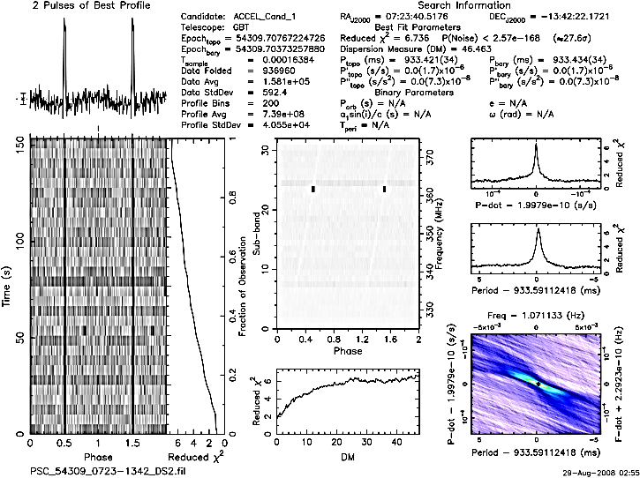

*Figure 1-4. This multiplot shows the effects of interference on a pulsar timing observation. Here the interference can be readily seen in the middle (phase) plot as lines across the frequency spectrum (circled in red). In this example, the interference results in the individual channels being removed from the data, reducing the overall sensitivity of the astronomical observations. (Data from https://pulsars.nanograv.org/examples)*

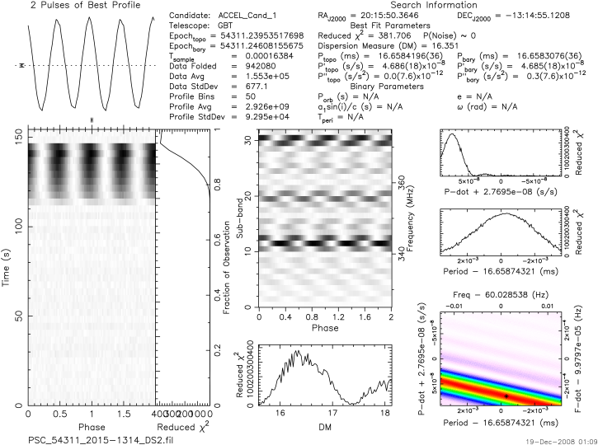

*Figure 1-5. This multiplot shows the effects of interference on a pulsar timing observation for a situation where the strength and breadth of the interference makes the data unusable for scientific purposes.. Here the interference can be readily seen in the middle (phase) plot as lines across the frequency spectrum (circled in red). The top left plot (“2 pulses of best profile”) shows only a ripple in the baseband, due to the presence of interference (orange square). (Data from https://pulsars.nanograv.org/examples)*

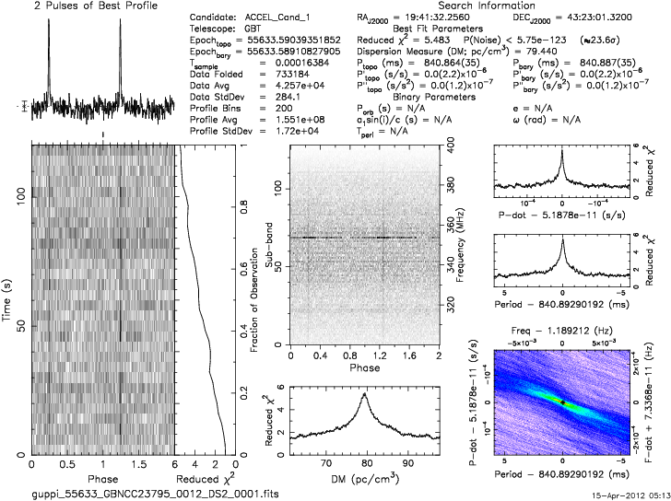

*Figure 1-6. This multiplot shows the effects of interference on a pulsar timing observation for a situation where the interference both makes the data unusable for scientific purposes and provides a signal that mimics many aspects of the astronomical signal of interest. Here the interference can be readily seen in the middle (phase) plot as lines across the frequency spectrum (circled in red) and the phase (circled in blue). The top left plot (“2 pulses of best profile; orange square”) shows what appears to be an astronomical signal, however the phase plot, which shows the signal is not changing in phase with frequency, indicated this is an earth-based and not astronomical signal. (Data from https://pulsars.nanograv.org/examples)*

*Synthesis Observations– Spectral Line Examples*

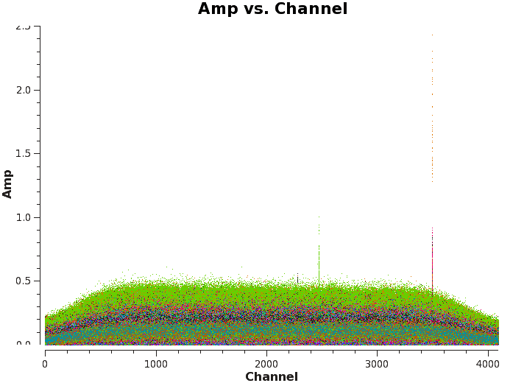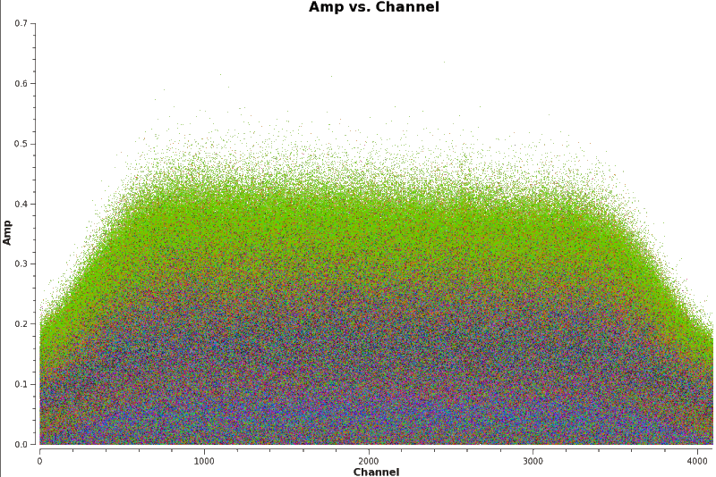

*Figure 1-7. These plots show the frequency channels versus amplitude for 25 separate antennae on the Very Large Array, with the antennae separated by color and each observation of a multi-hour observation shown as individual spectra. The left plot shows RFI in individual channels of a number of the antenna, in many cases present for most or all of the observations, albeit at a variety of amplitudes (intensities). The right plot is the same data, but with the channel and antenna combinations with obvious interference flagged and removed from the data.* *Images from https://casaguides.nrao.edu.*

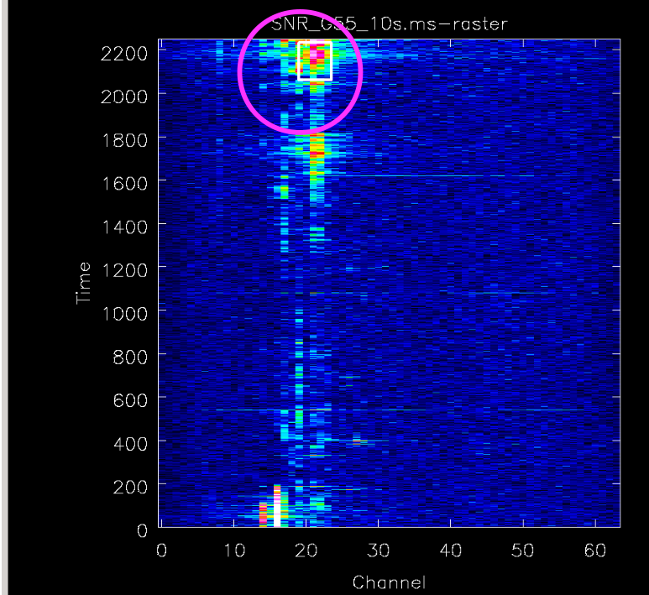

*Figure 1-8. These plots show the frequency channels versus amplitude for the processed (synthesized) data from all 25 separate antennae on the Very Large Array. Here there is clear interference which varies in time but which is present in the majority of the telescopes, making , scientific use of the data exceptionally difficult.* *Images from https://casaguides.nrao.edu.*

**A1.3 Interference Mitigation Technique Examples**

Here we describe the various methods for mitigating RFI, following the ordering and description of the methods within the report.

*Pro-active measures - Coordination*

Changes to the local RFI environment cannot be displayed in this annex, but an example of coordination with satellite operations is detailed in Annex 2.

*Pro-active measures – Filters*

Filters are commonly used in the case where the interference is stable and strong enough to cause concern with ringing and/or gain compression within the signal path.

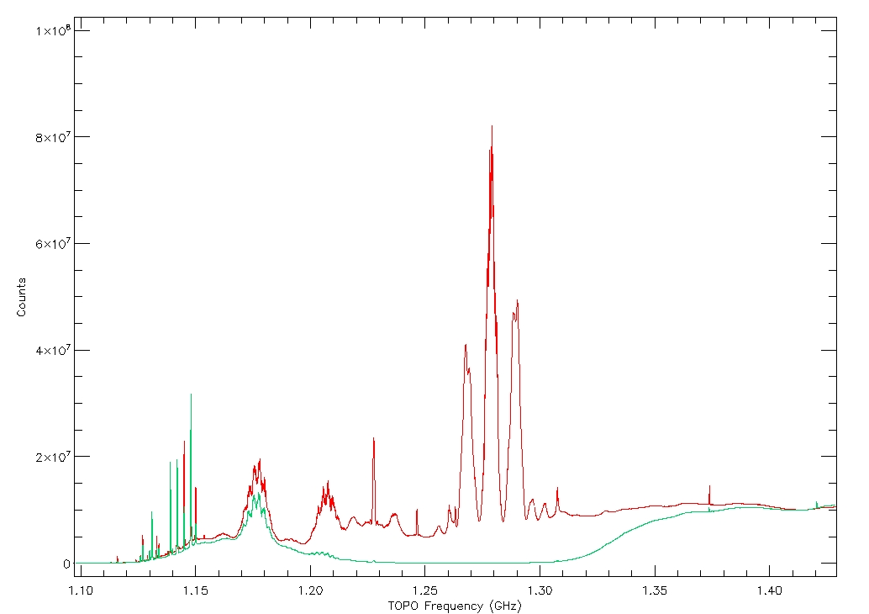

*Figure 1-9. Example of using a filter to remove interference before correlation. Here the filtered data (green) clearly avoids the interference shown from 1.25-1.35 GHz. The filter, though, also removes any possible detection across the entire 1.2-1.35 GHz band, and clearly reduces the signal seen from 1.15 – 1.4 GHz. Data taken with the GBT.*

*Pro-active measures – Robust Hardware Design*

Increasingly robust hardware allows for interfering signal to be isolated in the frequency channels affected by the interference. There are a variety of techniques possible here, including digitizing the signal as close to the feed horn(s) as possible and increasing the dynamic range of the signal processing hardware.

*Figure 1-10. Example showing the improvements in hardware design providing increased resistance to an interfering signal. Data in blue show a clear ringing patter in the frequency channels well outside the emitted frequency of the interfering signal. Data in orange was taken with the same telescope but with 16-bit, rather than 3-bit signal processing system, which has removed the ringing and greatly decreased the effects of the interference on the scientific data. Data taken with the GBT.*

*Spatial Excision (Nulling) - Multi-antenna Systems*

Many examples of spatial excision or nulling using multi-antenna systems can be found. The LoFar antenna (<https://www.astron.nl/telescopes/lofar/>) is an excellent example as it consists of many identical antenna scanning roughly the same sky area.

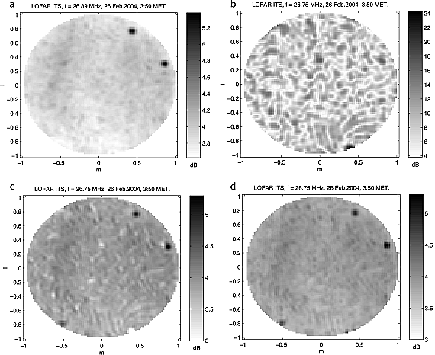

*Figure 1-11. Example of spatial filtering using the LOFAR ITS test station: (a) snapshot image without interference at 26.89 MHz, (b) snapshot image with a transmitter at 26.75 MHz, (c) image with transmission removed by spatial filtering using a projection filter, and (d) image with transmission removed by spatial filtering using a subtraction filter. Image from Boonstra & van der Tol (2011).*

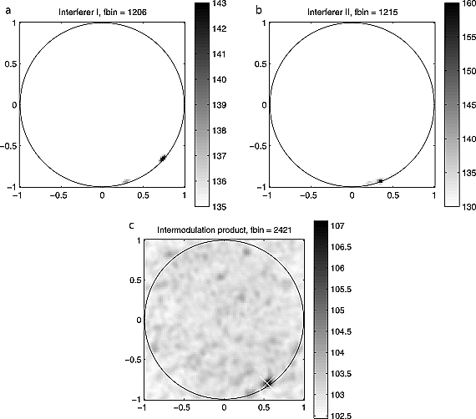

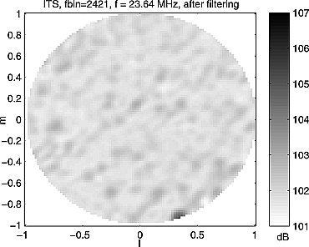

*Figure 1-12. Example of spatial filtering using intermodulation with the LOFAR ITS test station. Here there are two strong interfering point sources are visible at the horizon at (a) 11.77 and (b) 11.86 MHz. (c) The summed frequency intermodulation product is visible at a location in between the two “parent” sources. The intermodulation product is marked with a cross and remains a point source. (d) Shows the sky map showing the effect of a rank-1 spatial projection filter on an intermodulation product. The intermodulation product, a point source, is suppressed by at least 10 dB. Image from Boonstra & van der Tol (2011).*

*Spatial Excision (Nulling) - Subspace Projections*

Subspace projections, an alternative to the traditional Wiener filter-based null-forming techniques, has been tested on a number of systems. Use of the subspace projection technique has been demonstrated on a number of phased array feed systems, including those that have been tested at Green Bank Observatory.

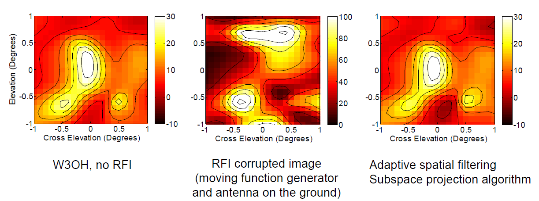

*Figure 1-13. Example of successful subspace projection using a 19-element phased array feed on the 20m diameter telescope in Green Bank, West Virginia. Image from Warnick (2014) and Landon, et al. (2009)*

*Spatial Excision (Nulling) - Post-correlation Beamforming*

[To be added.]

*Spatial Excision (Nulling) - Reference antennas and reference beams*

[To be added.]

*Wave form subtraction*

[To be added.]

*Anti-coincidence methods*

[To be added.]

*Temporal and Frequency excision – Temporal blanking*

[To be added.]

*Digital Excision at Correlation - Cyclo-stationary/Kalman tracking*

[To be added.]

*Digital Excision at Correlation - Spectral kurtosis*

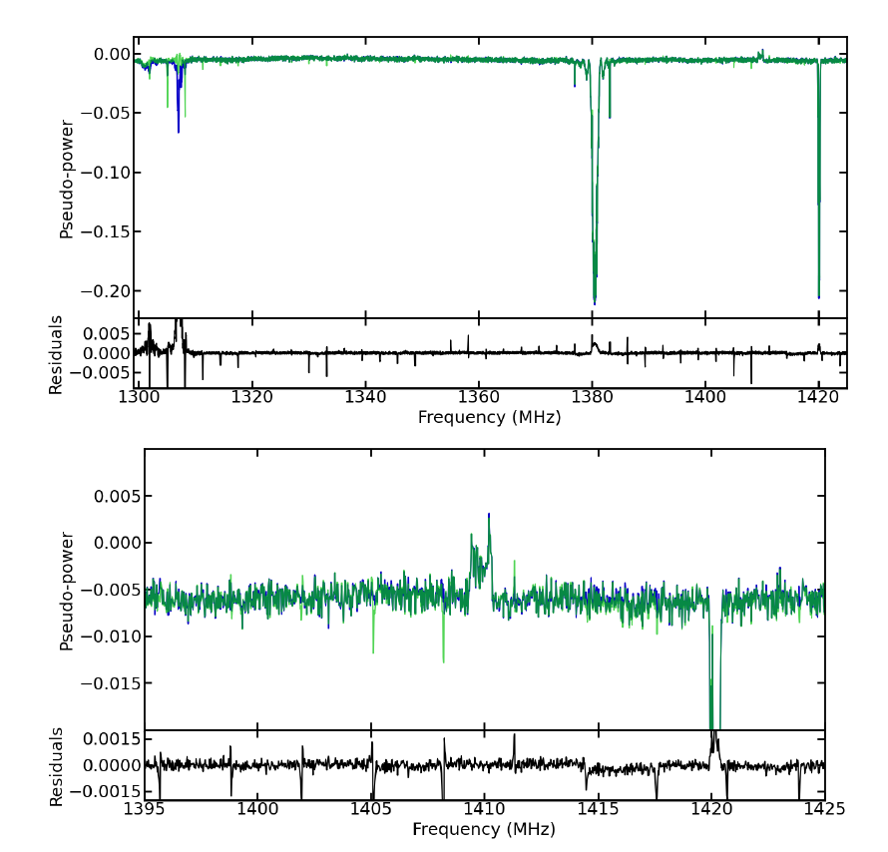

*Figure 1-14. Spectral Kurtosis technique applied to single dish spectral line data. Here both images are the same, but the top image shows the full bandpass and the bottom image is zoomed into show the astronomical signal of interest. In this case spectral kurtosis made no change to the astronomical data of interest, and was successful in flagging some of the interference (at 1302 MHz). However, the technique only flagged the GPS L3 signal at 1380 MHz (see inverted in the plots), and often flagged the astronomical data from our own galaxy (at 1420 MHz). Data and further information on these plots can be found in Smith (2022).*

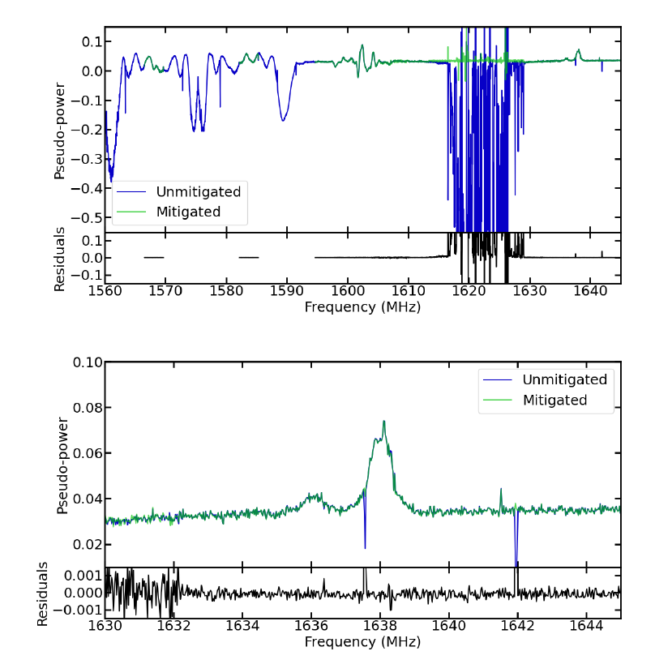

*Figure 1-15. Spectral Kurtosis technique applied to a second set of single dish spectral line data. Here both images are the same, but the top images shows the full bandpass and the bottom image is zoomed into show the astronomical signal of interest. In this case the astronomical signal was undetectable prior to the spectral kurtosis technique, but was successfully recovered after the technique was applied. Data and further information on these plots can be found in Smith (2022).*

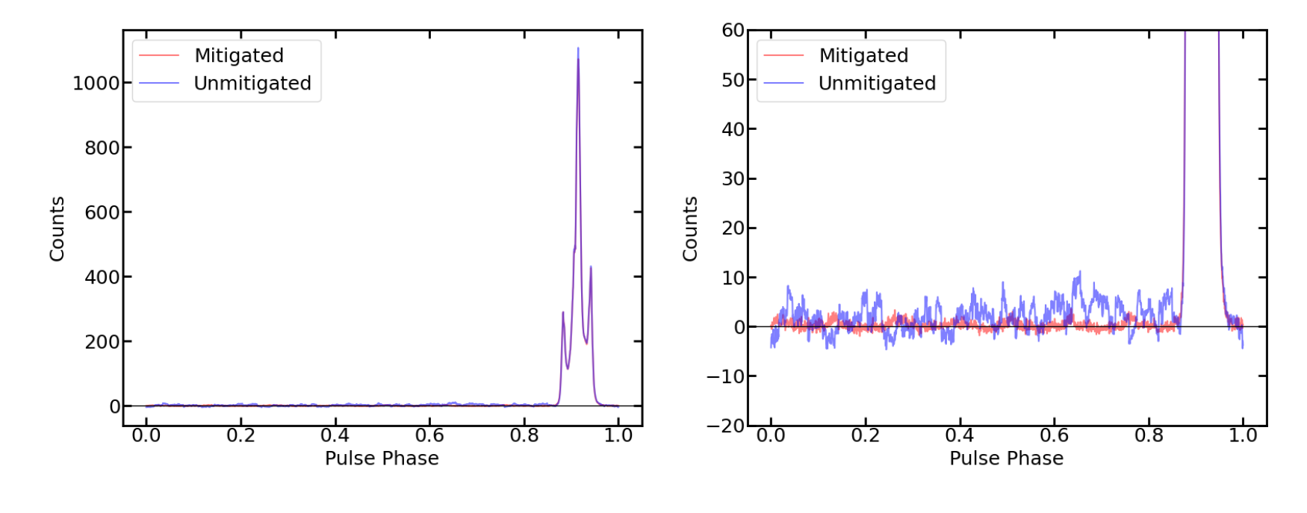

*Figure 1-16. Spectral Kurtosis technique applied to a s single dish pulsar (total power) data. Here both images are the same, with the unmitigated data in blue and the mitigated data in red. The left images show the intensity and the right image is zoomed into show the baseline.. In this case the astronomical signal was unaffected by the spectral kurtosis technique, but the removal of interference from the data significantly reduced the r.m.s. noise in the data. Data and further information on these plots can be found in Smith (2022).*

*Digital Excision at Correlation - Synthesis techniques (fringe stopping/delay compensation)*

[To be added.]

*Post-correlation – Flagging/Blanking Examples*



*Figure 1-17. Flagging a single channel of RFI from single dish spectral line data. Left: The original data, processed to show the astronomical signal, but also interference. Right: The channels with interference were flagged and replaced with the average values from the two neighboring channels, removing the interference and readily recovering the astronomical signal.*

Frequency

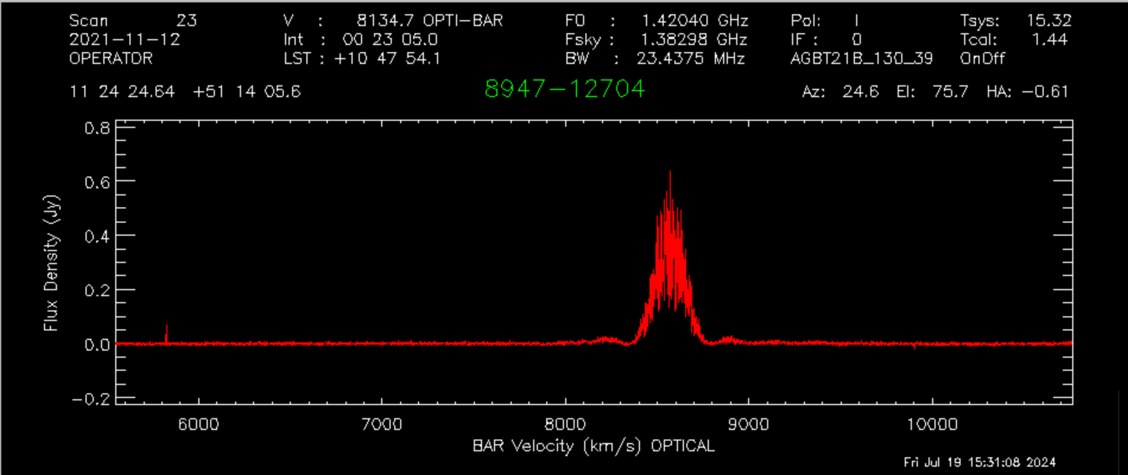

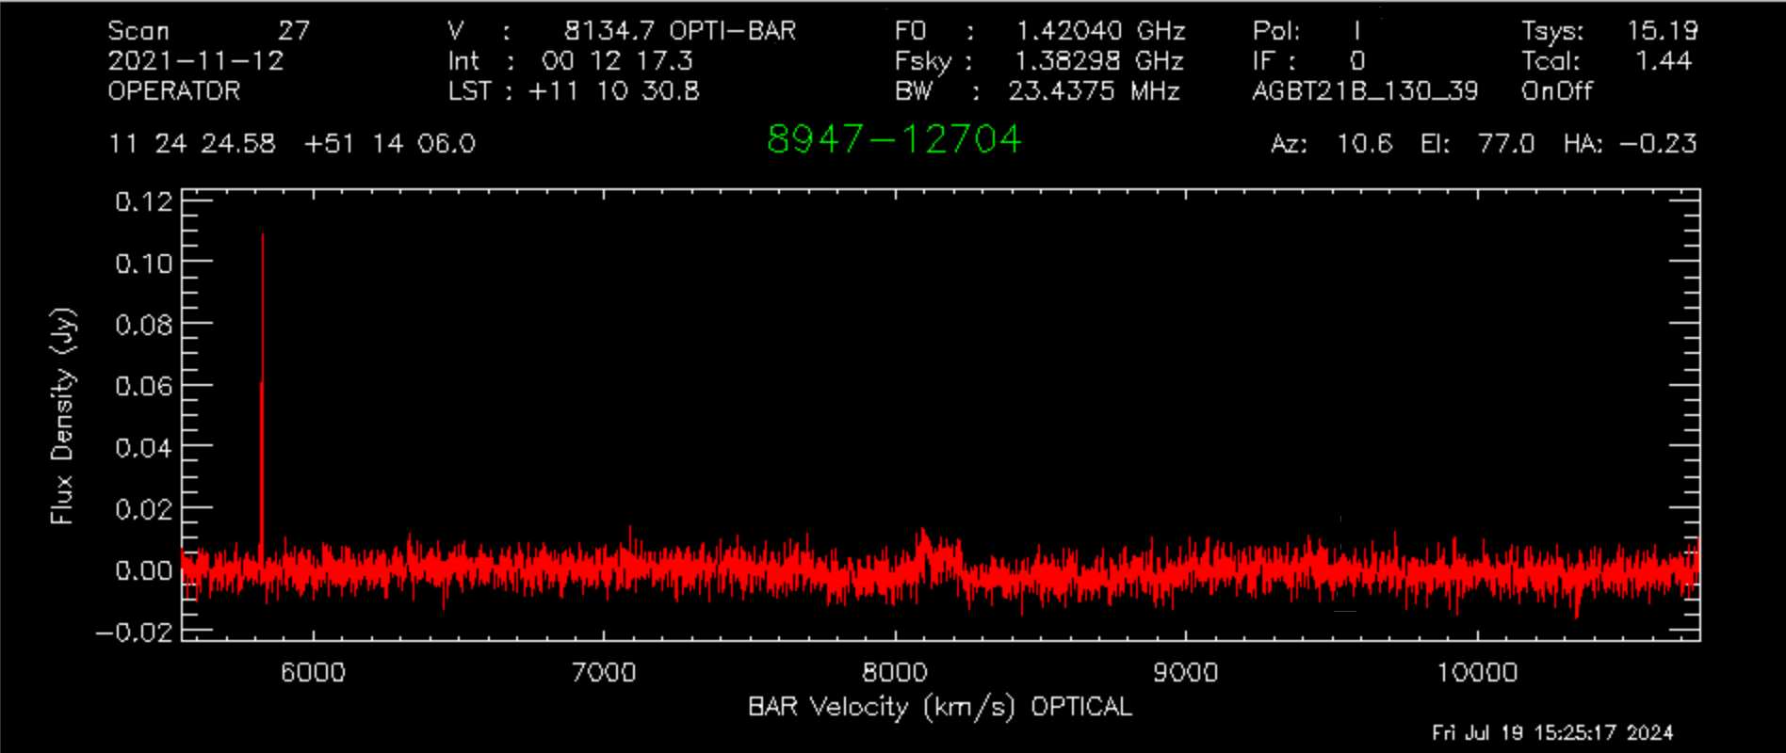

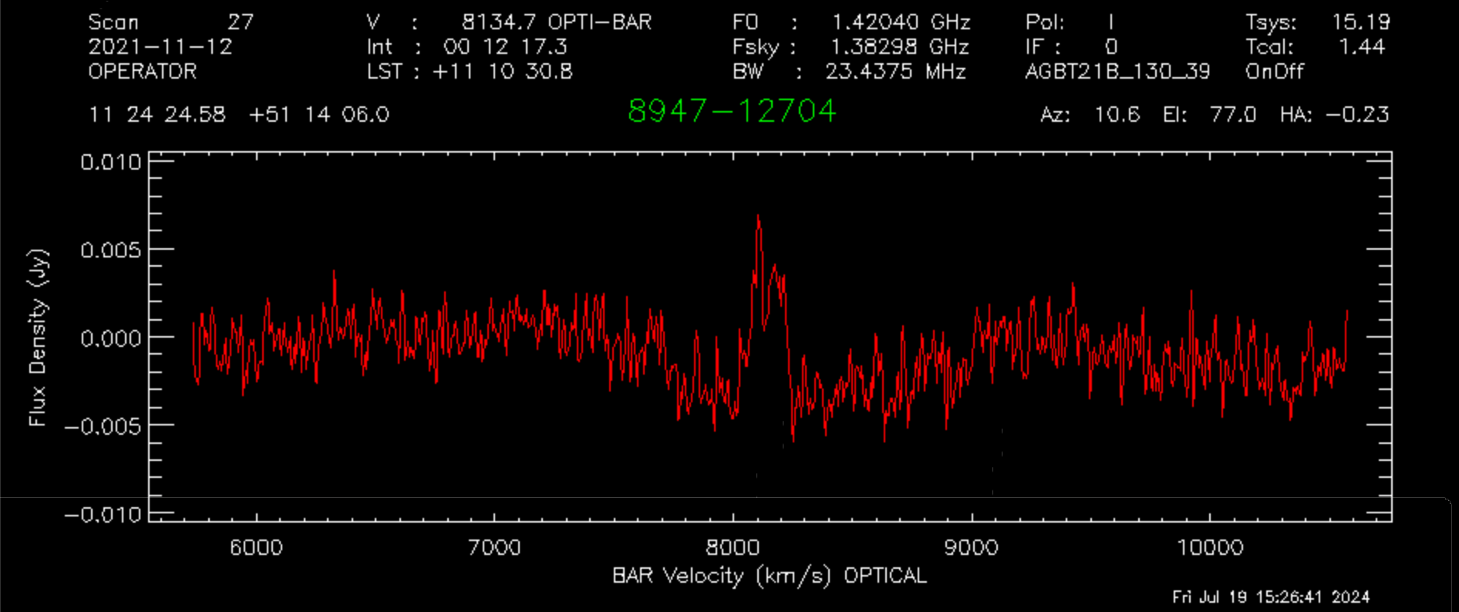

*Figure 1-18. Flagging a strong, multi-channel RFI signal from single dish spectral line data. Top: The original data, processed to show the astronomical signal, but also interference. Middle: the data again, here with all integrations (temporal) which have the signal flagged and removed. Bottom: The same as middle, but with the spectral data smoothed to readily display the astronomical signal. In all approximately 600s (47%) of the data had to be removed from the observations to allow for recovery of the astronomical signal. Data from K. Masters and D. Stark and taken with the GBT.*

Annex 2

Application of an Operational Data Sharing system at Green Bank Observatory (GBO) and Karl G. Jansky Very Large Array VLA

Two telescopes, the Green Bank Telescope (GBT) and Very Large Array (VLA) have been involved in experiments to detect transmissions from satellite systems, and reduce the strength of those signals when possible.

The GBT, situated in the U.S. National Radio Quiet Zone (NRQZ), has been involved in coordinated and uncoordinated experiments to detect both uplink and downlink transmissions from satellite constellations and ground terminals. Experiments began in Spring 2022 with the deployment of a User Terminal of an operating satellite constellation at a variety of locations near the GBT.

An example of these early experiments is described in NRAO RFI Memo 154: Coordinated GBT-Starlink Tests (April-July 2023): <https://library.nrao.edu/public/memos/rfi/RFI_154.pdf>. The first successful test of Operational Data Sharing (ODS) by a satellite constellation operator is described in a peer reviewed article, Nahn et al (2024).

Fig. A2.1 A 1-s scan taken with the telescope at 25 degrees elevation, pointing N. Many 1-s scans look like this with little to no emission evident in the frequency range 11.45-11.95 GHz (downlink Channels 4-5).

Signal levels in these early tests were consistent with expectations (see Fig A2.1), based on a simple model of the downlink beam characteristics and the telescope response. Figure A2.2 below, illustrates the ability to detect NGSO satellite downlink transmissions (at the level of a few Jy[1]). Signals like this are typically very short duration, lasting for only 1- or 2-s.

Fig. A2.2 Showing the impact of timing and polarization. (Left) A 1-s scan taken with the telescope at 25 degrees elevation, about 9 seconds later than the scan in Fig. A2.1. (Left) shows the spectrum in RHCP signal showing a downlink transmission from an NGSO satellite, and (Right) shows the spectrum in LHCP (at the same time; no signal apparent due to the polarization of downlink signals). The characteristic ~250 MHz-wide downlink signal occupies 11.7-11.95 GHz. This result is not surprising, since the downlink signal in 10.7-12.7 GHz is a RHCP signal. The emission disappears at this same time in the LHCP plot, as expected. This detected signal strength is consistent with a GBT sidelobe interacting with a satellite main lobe.

Another signal, detected in an experiment performed on August 26, 2023 shows that when a satellite comes very close to the telescope boresight, very large signals can be detected (see Fig. A2.3).

Fig. A2.3 A 1-s scan taken with the telescope at 35 degrees elevation. This emission is likely the result of a downlink signal between the GBT-main lobe and the satellite-sidelobe.

Similar experiments were carried out at the VLA, beginning in Fall of 2021. Starting with the deployment of a User Terminal to a number of locations around the VLA, and progressing to the regular monitoring of the specific satellite uplink and downlink frequencies as a way to gauge the impact of the deployment of ~60 User Terminals to family compounds located on the Alamo Navajo Reservation.

The Alamo reservation (located to the NE of the N arm of the VLA) highlights the issues of broadband internet access in remote locations. In some ways, satellite internet from NGSO satellites are an ideal solution to this diffusely populated region. However, questions remained about the impact of downlink and uplink signals in this close proximity to the North arm of the VLA. Topography has helped, given that the reservation population is mostly located on the far side of a mountain ridgeline. Regular monitoring through two full configuration cycles of the VLA indicates that the location of those 60 devices does not negatively impact observations at the uplink and downlink frequencies of this particular satellite constellation (for more information see EVLA Memo No. 223 https://library.nrao.edu/public/memos/evla/EVLAM_223.pdf).

The ODS system was deployed at the VLA in May 2024 for fully autonomous operation test. Unlike previous tests, there was no coordination between NRAO and the satellite operator other than agreeing on the time span of the operation. In this test, the satellite operator took two different operations, steering downlink beams away from the site if the satellite was between 0.5 and 1.0 degrees from boresight, and disabling all beams if the satellite was between 0.0 and 0.5 degrees from boresight. These paremeters may change as the interactive system evolves.

Figures A.2.4a and A.2.4b show the results of ODS and the satellite operator’s boresight avoidance system. Fig. A2.4a shows results with the system deactiviated, and Fig. A2.4b shows results with the system activated.

Fig. A2.4a Examples of the spectra from the right-handed circular polarization (RR) recorded in the SpB-C (10.6-12.0 GHz) during Experiment #1, when boresight avoidance was not activated. (*Left*) Observed spectra recorded with the RA-band, downlink Channel 1-5 with Starlink passages for Δθbs≤0.5∘. (*Right*) Observed spectra recorded in the SpB-C with satellite passages for Δθbs>0.5∘. Satellite passages are shown with the satellite ID and boresight separation in degrees annotated in the legends. Additionally, each panel contains an inset showing the measured power (in logarithmic scale) at one of the passband frequencies within each downlink channels over twelve seconds, centered about the closest passage. In this experiment, the rise and fall of the power correlate with the satellite passages traversing the GBT’s main beam, which will be traced out more accurately with higher time resolution in future experiments. Depending on the positioning of the downlink beams relative to the telescope, not all passages peak at the same time as when the satellites are closest to the telescope boresight.

Fig. A2.4b Examples of the spectra from the right-handed circular polarization (RR) recorded in the SpB-C (10.6-12.0 GHz) during Experiment #2, when the boresight avoidance was activated for satellite passages with Δθbs≤0.5∘. (*Left*) Observed spectra recorded with the RA-band, downlink Channel 1-5 with Starlink passages for Δθbs≤0.5∘. (*Right*) Observed spectra recorded in SpB-C with satellite passages for Δθbs>0.5∘. Each panel contains an inset showing the measured power at one of the passband frequencies within each downlink channels over twelve seconds, centered about the closest passage. In this experiment, the rise and fall of the power are only observable for passages with the closest boresight separation outside the 0.5∘ cutoff.

Of course, the ODS system has limitations as well which should be noted, including: (1) the need for telescopes to provide advance notice of their pointing positions and frequencies, (2) the challenges of keeping satellite beams and out of band emission out of telescope sidelobes, and (3) the inability of all satellite systems to implement this system from the constellation side (e.g. utilizing beam steering to direct beams away from telescopes in a dynamic fashion.

1. 1 Jy corresponds to -204 dBm